"Your video card driver does not support the selected Vulkan version" Message upon Godot Module Launch
Operation of the Godot Module requires Vulkan API.
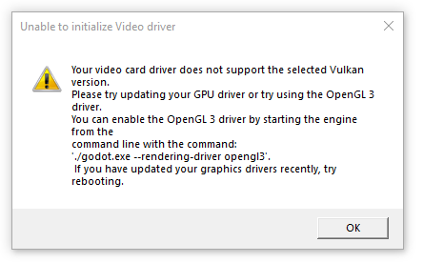
If you get error messages when launching the Godot module, you need to install a video card driver that supports the Vulkan API. OpenGL is not supported.
To view the Vulkan SDK library version installed on the server, you can use the OpenGL Extension Viewer app.


