Tracking Data Transmission Simulator
The Panasonic AW-UE150 camera simulator from DisruptAR will be useful for developing and testing projects for Godot Engine if a real camera with tracking is not available.
The simulator creates Free-D packets and broadcasts them over a specified UDP socket, just like a real camera does. You can run multiple instances of the application to simulate multiple cameras (IP addresses and port numbers must be unique).
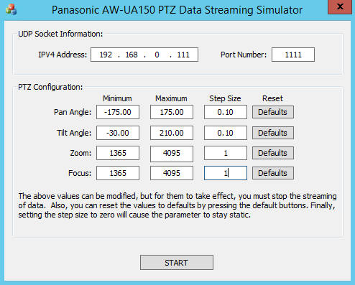
Parameter | Description
Pan Angle | Tilt Angle
Tilt Angle | Tilt angle
Zoom | Zoom value
Focus | Focus setting
Minimum | Minimum value of parameter
Maximum | Maximum value of the parameter
Step Size | Step Size. Setting the step size to 0 (or 0.0) will cause the parameter to remain unchanged.
START | The button starts the data translation. When you press START the application starts broadcasting Free-D packets at about 60 frames per second. Each value of the Free-D parameter starts with a minimum and increases each frame in steps. After reaching the maximum value, the value will decrease each frame by the step value until it reaches the minimum, then the process repeats.
STOP | Button to stop data broadcasting.

