Multicamera Function (Multicamera Clips)
A multicamera clip allows you to select a camera during playback. Any clips in the media database will be considered multicamera if their mediaid will be in the following format: base_name-{k}, where base_name is an arbitrary clip name, k is the video track (camera) number from 1 to 16.
This function can be used together with function Screen Output (output images to projectors and video walls in scenery).

Creating
Multi-camera clips can be produced as follows:
- Recording with the LSM module (Instant replay or slow motion)
- Recording with RecManager in multi-camera recording mode
- Multiple clips can be renamed manually to have the same base name and appropriate suffixes (-{k}).

Processing
Trimming or keyframe addition operations in MediaBrowser / FileMonitor for one multi-camera clip are automatically applied to other clips with the same base name.

Viewing
In File Monitor, you can easily switch between cameras by pressing the corresponding number (1, 2, 3, etc.) button on the keyboard.

Playback

As a single clip in a playlist (simple mode)
Any multi-camera clip can be queued for playback in the programme channel playlist.
The camera is selected in the Change camera... item available in the right-click menu when clicking on a multi-camera clip in the playlist. The clip with the MediaId specified in the Media column of the playlist will be played.

As a camera group in ProgramOutput (multi-camera mode)
Starting with version 2.0.52, there is a new option in the ProgramOutput configuration: Administrator Control Panel→Manage→Program Outputs→Program output N→Playout Parameters→Multicamera
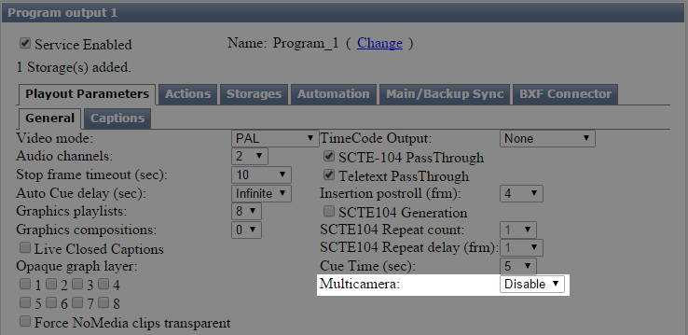
Option Value | Description
Disabled | The option is set to “Disabled” by default, which means that the programme channel operates in simple mode.
1-8 | Select the number of cameras. Switches the ProgramChannel to multi-camera mode with the number of outputs corresponding to the selected value.
If multi-camera mode is selected, ProgramChannel creates a number of internal output streams: “SERVICE_NAME CAM#” where SERVICE_NAME is the name of the programme channel and # is the selected number of cameras.
These streams can be associated with the physical outputs of one or more graphics cards.
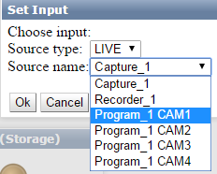
When playing back multi-camera clips, cameras are automatically routed to internal output streams according to their number. Example:
- Clip base_name-{1} → Programme_1 CAM1
- Clip base_name-{2} → Programme_1 CAM2
- …
- Clip base_name-{#} → Programme_1 CAM#
All actions such as “Set Background”, “Set Logo”, etc. are routed to all outputs equally.
If a simple clip that does not have a multi-camera suffix (-{k}) is played in this mode, it will play in parallel in each output stream.

