Garbage Collect
Some users may experience a storage overflow problem, where links to files are removed from the media database, but physically files remain on the disk array. This occurs due to files being blocked by some process at the moment of deletion.
Garbage Collect was created (added in version 1.8.113) to search for broken links and unnecessary files in the database.
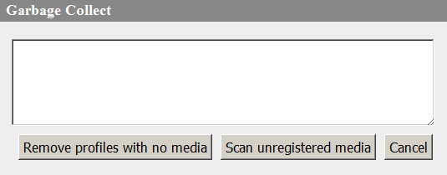
The Garbage Collect configuring window: Administrator Control Panel → Status Tab → Database Name (Storage) → Garbage Collect…
To edit this option, you must be authorized as an administrator, or a user with appropriate rights. If Enable local admin privileges is on, authorization is not necessary (User and Password fields are empty).
Option | Description
Remove profiles with no media | Deleting profiles (LRV, BRV not on volumes, WP1, WP8) with no actual files. The situation only occurs during backups. The option is available starting from version 2.0.53. 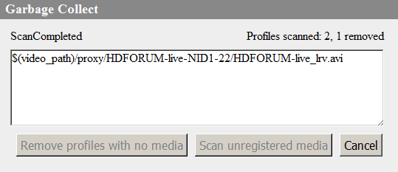.
Scan unregistered media | Searching for lost files. Clicking opens the search area selection dialog:  - MEDIA – the media database,  - ARCHIVE – the archive folder (if configured).  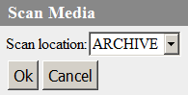  Scanning shows the total number of lost files and links to them. The listed files can be removed by Remove unregistered media.
Remove unregistered media | The option is activated after completing a Scan unregistered media.  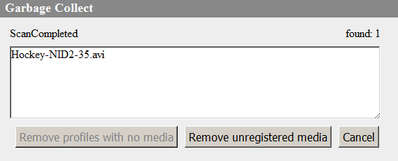  Deletes files with no links in the media database. After successful deletion, the message appears:: Deletion completed N of N.

