Skylark BMPlayer
SkyLark® Broadcast Media Player is the program player for viewing media files, displaying SDR/HDR streams SDI, MPEG or SMPTE2110 Transport Stream over IP and visualization of supporting data (Ancillary data and DVB-data).
Broadcast Media Player is created specifically for professional application in Television Broadcasting & Production and works in the Windows environment.
The key features of the player are:
- Frame-by-frame viewing of media-files.
- Viewing files with a 32-bit alpha channel.
- Support of the level indication and the option of listening up to 64 sound channels.
- Displaying presence of ANC data.
- The option of viewing HDR files on the SDR monitor.
- Autonomous viewing of graphic compositions exported to SLG files.
- The option of image output to the external SDI control monitor.
- Support of viewing closed Teletext captions from VANC/VBI and captions from files (SRT, SMI, TTML, STL).
- Support of SMPTE2110/NMOS, SDI and NDI.
- Decoding and playout of multichannel AC3 sound.

Installation
The BMPlayer distribution kit is supplied as an MSI packet. Installation of application components is implemented to the C:\Program Files\BMPlayer directory.
In the moment of installation the player is registered in the File Explorer context menu, allowing for opening files via the right-click menu (the setting may be changed in the File→Configure→Register file associations menu).
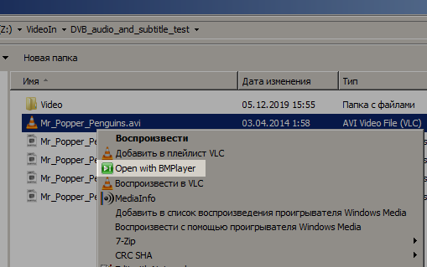

Licensing
The BMPlayer application is protected from copying by the program key that depends on the used hardware and some other components.
More details on licensing.

Interface
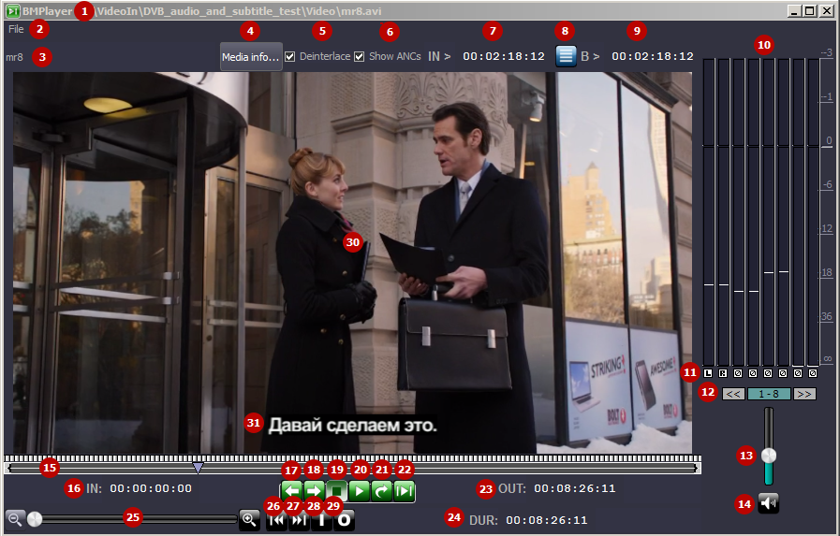
Interface element | Description
1 | The disk path to the clip loaded to the viewing window
2 | The File menu  - Open Media… - opens the dialog for selecting the file at the disk.  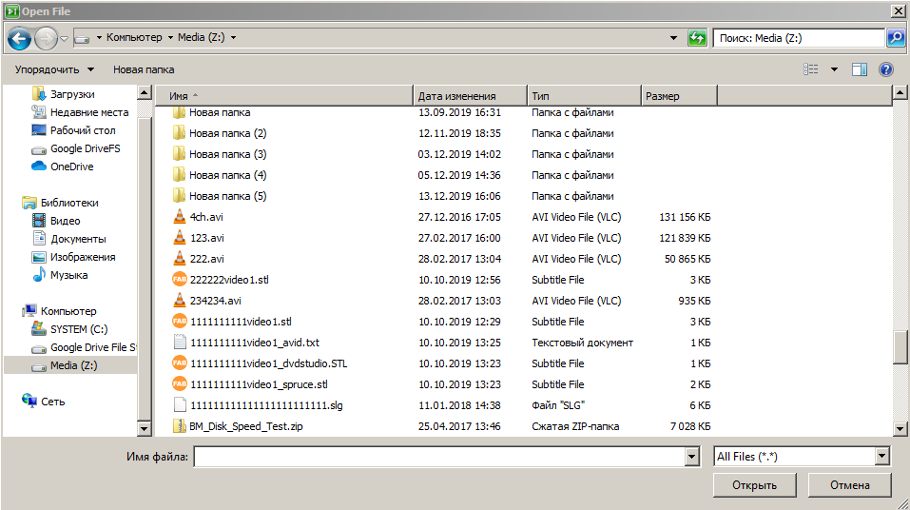  - Open SMPTE-2110/NMOS… - opens the dialogue for configuring SMPTE-2110/NMOS sources for viewing.  - Open SDI… - opens the dialogue for selecting the SDI source for viewing.  - Open NDI… - opens the dialogue for selecting the NDI source for viewing.  - Close Media - closes the viewed file without closing the player interface.  - Configure - opens the window with player settings.  - License - opens the window with the license information.  - About - opens the window with the player version information.  - Exit - exits the application.
3 | The name of the clip loaded to the viewing window
4 | The Media info button opens the window with the clip information. Output of the following data is supported:  - File - the disk path to the loaded clip.  - Frame rate - the clip frame frequency.  - In point - the IN point value.  - Out point - the OUT point value.  - Duration - the clip duration.  - Orig In - the initial point of the clip start.  - Orig Out - the initial point of the clip end.  - Comment - the clip description read from a text file. The text file name must have the .txt extension and the name that coincides with the clip name.  - Width - the frame width in pixels.  - Height - the frame height in pixels.  - Codec - the used codec (e.g., h264).  - Aspect - the aspect ratio (e.g., 16×9, Full Frame).  - Color - the clip color profile (e.g., Arib-std-b67 for HDR HLG).  - ANC Data - information on presence of ANC data for the played clip. Possible values:  - NONE - no data.  - VANC DBG - the files was recorded with the activated Debug VBI function.  - TTX-B-625 - teletext data is present.  - SCTE-104 - SCTE messages.  - CC CEA-608/CEA-708 - closed captions.  - AFD - presence of the AFD code, etc.  - Caption Files - displaying the connected caption tracks and their language. An example: Stream 1: Unknown.  - Rate - sampling rate (the number of samples per second).  - Bps – bitrate (bits per second).  - Channels - the number of sound channels.
5 | Deinterlace - activating the deinterlacing mode upon image output.
6 | Show ANCs - activates displaying of ANC-data (SCTE messages, AFD, captions, etc.)
7 | The current cursor position from the IN mark. Click on this field to edit the value. The field format: HH:MM:SS:FF (or HH:MM:SS;FF for the NTSC format), where: HH - hours, MM - minutes, SS - seconds, FF - frames.
8 | - the button opens the dialogue for managing the function of captions preview (SRT/SMI/STL/TTML, 608/708, Teletext).  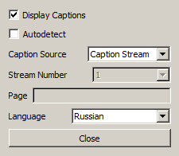  - Display Captions - activate displaying of captions (the file must contain captions). The captions appearance is configured in the menu: File→Configure→Caption Preview.  - Autodetect - automatic selection of the caption source.  - Caption Source - manual selection of the caption source:  - Empty value - source not defined.  - СС-608 - closed captions by the CEA-608 standard.  - СС-708 - closed captions by the CEA-708 standard.  - Teletext - captions in teletext (specifying the page number is required).  - Caption Stream - captions from files.  - Stream Number - selecting the stream number for displaying the corresponding subtitle track (used if Language=Any).  - Page - selecting the teletext page (for the Teletext mode).  - Language - selecting a language for displaying the corresponding subtitle track (used if the Stream Number value is not defined).
9 | The current cursor position from the material start (BEGIN). Click on this field to edit the value. The field format: HH:MM:SS:FF (or HH:MM:SS;FF for the NTSC format), where: HH - hours, MM - minutes, SS - seconds, FF - frames.
10 | Audio level indicator (DBFS scale).
11 | Every bar has a switch at the bottom that implements channel output to the audio playback device at the client PC:  - L - output of the selected audio channel to the left channel.  - R - output of the selected audio channel to the right channel.  - A - output of the selected audio channel to both channels.  - X - output of the selected audio channel is turned off.
12 | The switcher of displayed audio level indicators appears in case when the number of active indicators exceeds eight.
13 | Volume controller for viewing at the playback device (e.g., a client PC sound card).
14 | The button for turning off sound output.
15 | The timeline.  - { - The IN point.  - } - The OUT point.  - V - The grey cursor for the current clip viewing position.
16 | The IN point value. Click on this field to edit the value. The field format: HH:MM:SS:FF (or HH:MM:SS;FF for the NTSC format), where: HH - hours, MM - minutes, SS - seconds, FF - frames.
17 | The frame-by-frame reverse playback button.
18 | The frame-by-frame playback button.
19 | The Stop button to stop playback.
20 | The Play button to launch playback.
21 | The button launches cyclic playback of a fragment set by IN-OUT points.
22 | The button launches playback of a fragment set by IN-OUT points.
23 | The OUT point value. Click on this field to edit the value. The field format: HH:MM:SS:FF (or HH:MM:SS;FF for the NTSC format), where: HH - hours, MM - minutes, SS - seconds, FF - frames.
24 | The clip duration value. Click on this field to edit the value. The field format: HH:MM:SS:FF (or HH:MM:SS;FF for the NTSC format), where: HH - hours, MM - minutes, SS - seconds, FF - frames.
25 | The controller and buttons for scaling the timeline.
26 | The button for transition to the IN point.
27 | The button for transition to the OUT point.
28 | The button for setting the IN point in the current cursor position.
29 | The button for setting the OUT point in the current cursor position.
30 | The viewing window. If the clip for playback is not loaded, the VIDEO OFFLINE message will appear. Extra features:  - Right-click the display area to Start/Stop playback.  - Double-click by any mouse button the display area to maximize the image to fullscreen.
31 | Output of captions in the preview window.

Safe Area Frame
Since the version 2.6.117, there is an option to turn on displaying of safe area frames in the viewing window. To activate the frame, use the Area switcher in the top part of the screen.
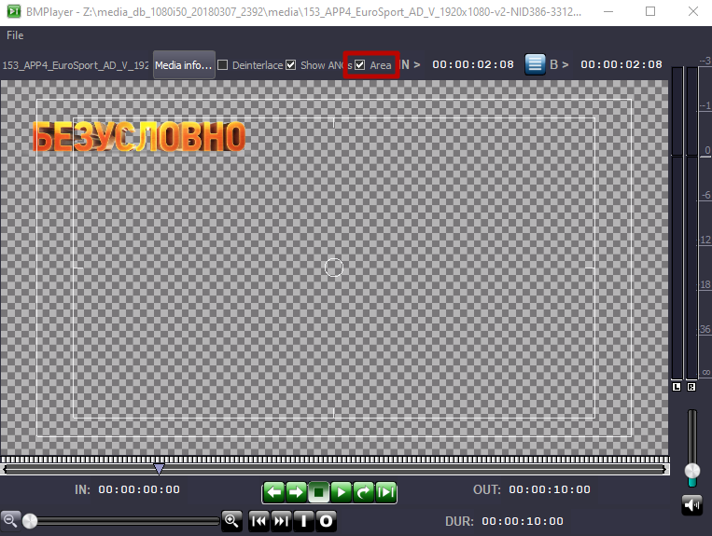

Settings

General
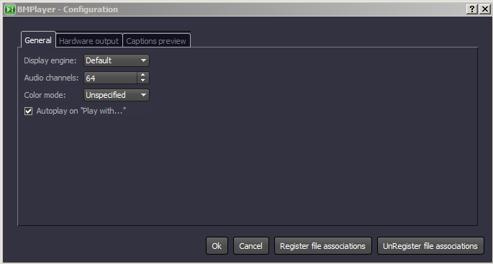
Parameter | Value
Display engine | Selecting the video display technology in the viewing window. The choice depends on work features of a client PC video card with BMPlayer launched. Sometimes, motherboard integrated video cards won’t display video in the Default mode. In this case, select the necessary mode from the list and reload the application. Supported modes:  - Basic GDI  - Basic GDI HQ (recommended)  - OpenGL  - Default
Audio channels | The number of used audio channels. Level indicators will be displayed to the right from the viewing area. The option allows listening to up to 64 audio channels upon viewing materials at the client station.
Color mode | Setting the color space upon viewing files in the viewing window:  - Unspecified  - BT.601  - BT.709  - BT.2020  - SMPTE ST 2084  - ARIB STD-B67
Autoplay on “Play with…” | If the option is active, playback will start automatically after opening the file via the “Open with BMPlayer” menu.
Register file assiciations | Activates displaying of the “Open with BMPlayer” item in the File Explorer context menu for supported file types.  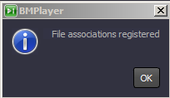
UnRegister file associations | Turns off displaying the “Open with BMPlayer” item in the File Explorer context menu.  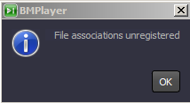

Hardware Output
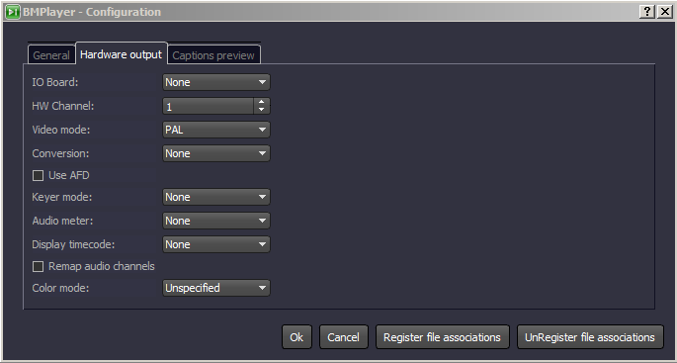
Parameter | Description
IO Board | Selecting the type of a hardware output platform (board) installed at the PC. The following boards are supported:  - Matrox DSX board,  - DekTec DTA board (SDI only),  - BlackMagic Decklink board,  - Computer Screen - the client station video card.
HW Channel | The number of a physical playout channel (port) of the output board, which will be used for displaying by BMPlayer. You should avoid conflicts while setting this parameter (no other software, including SL NEO server software, must use the port set for BMPlayer).
Video mode | Selecting the display format.
Conversion | Setting the Up/Down conversion mode.
Use AFD | The enabled option allows the player to select the conversion algorithm (scale, crop, box, letterbox) automatically, depending on the format of the initial frame and the AFD value associated with it.
Keyer mode | The mode when a board can form a pair of Fill+Key signals upon viewing 32-bit video with an alpha-channel (the External mode developed for Matrox DSX boards).
Audio meter | Activates the audio level indicator upon viewing through the output board.
Display timecode | Activates the counter displaying the cursor current position in the BMPlayer window (timecode format) upon viewing via the output board.
Remap audio channels | Activates support of sound streams redirection upon output to the board. Control is implemented by the switches under the level indicators.
Color mode | Setting the color space upon viewing files through the external monitor:  - Unspecified  - BT.601  - BT.709  - BT.2020  - SMPTE ST 2084  - ARIB STD-B67

Captions Preview
The Captions Preview tab serves to configure displaying closed captions in the viewing window in case, if the Display Captions option is active.
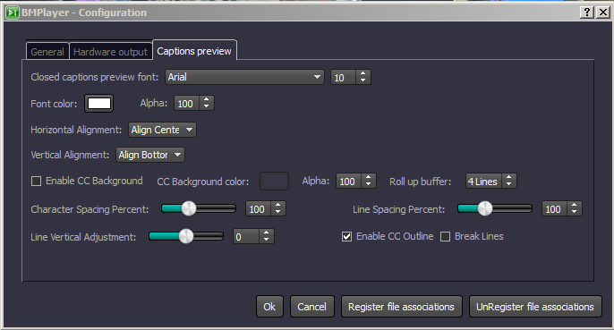
Parameter | Description
Closed captions preview font | Setting the font for displaying closed captions.
Size | The font size
Font color | The font color
Alpha | The font transparency: 100% - completely opaque.
Horizontal Alignment | Horizontal alignment.
Vertical Alignment | Vertical alignment.
Enable CC Background | Enable background for subtitle lines.
CC Background color | Setting the background color.
Alpha | The font transparency: 100% - completely opaque.
Roll up buffer | The number of scrollable lines.
Character Spacing Percent | The character spacing interval.
Line Spacing Percent | The line spacing interval.
Line Vertical Adjustment | Adjusting vertical alignment.
Enable CC Outline | Activates outline for letters.
Break Lines | Activates word wrapping.

Viewing External Signals
BMPlayer supports viewingsignals from SMPTE-2110/NMOS, SDI and NDI sources.

SMPTE-2110/NMOS
Viewing SMPTE-2110 streams is supported by any Ethernet adapters, including Mellanox boards without using Rivemax. Using Mellanox with Rivermax, however, is preferable, as it decreases the CPU load. For viewing SMPTE-2110/NMOS, open the dialogue for configuring the sources: File→Open SMPTE-2110/NMOS….
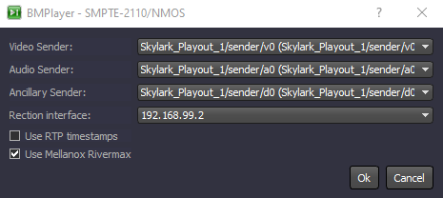
Parameter | Description
Video Sender | Selecting the video data source registered on the network.
Audio Sender | Selecting the audio data source registered on the network.
Ancillary Sender | Selecting the ANC data source registered on the network.
Rection interface | The network interface that will retrieve the data.
Use RTP timestamps
Use Mellanox Rivermax | Activates using API Rivermax with Mellanox boards.

SDI
Viewing SDI streams is supported with using Blackmagic Decklink boards. To view SDI, open the dialogue for selecting the source: File→Open SDI….
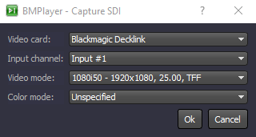
Parameter | Description
Video Card | Selecting the capture board. Blackmagic Decklink boards are supported.
Input channel | Selecting the board channel used to capture SDI signals.
Video mode | Select the video mode for the input stream.
Color mode | Select the output color space. Unspecified - playback will be implemented without conversion.

NDI
Viewing NDI streams is supported by any Ethernet adapters. To view NDI, open the dialogue for selecting the source: File→Open NDI….
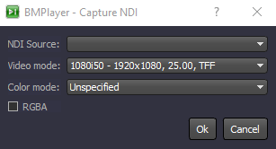
Parameter | Description
NDI Source | Select the NDI signal source available in the network.
Video mode | Select the video mode for the input stream.
Color mode | Select the output color space. Unspecified - playback will be implemented without conversion.
RGBA | Activating the viewing mode with Alpha support.

Hotkeys Combinations
Combination | Action
<Left> | -1 frame
Shift+<Left> | -5 frames
Ctrl+<Left> | -10 frames
Ctrl+Alt+<Left> | -1 sec
<PgUp> | -3 sec
Shift+<PgUp> | -10 sec
Ctrl+<PgUp> | -30 sec
Ctrl+Alt+<PgUp> | -1 min
<Right> | -1 frame
Shift+<Right> | +5 frames
Ctrl+<Right> | +10 frames
Ctrl+Alt+<Right> | +1 sec
<PgDn> | +3 sec
Shift+<PgDn> | +10 sec
Ctrl+<PgDn> | +30 sec
Ctrl+Alt+<PgDn> | +1 min
<-> | Slowing down playback. Playback speed is adjusted gradually, with the 0.1x pace. Hold the button to get the needed speed.
<+> | Increasing playback speed. Playback speed is adjusted gradually, with the 0.1x pace. Hold the button to get the needed speed.
<=> | Getting back to the regular playback speed (1x).

FAQ

Do I need to install codecs for BM Player to work?
The BM Player distribution kit contains the set of necessary codecs: DV/DVCPRO, DVCPROHD100, IMX, XDCAM EX/HD/HD422, PRORES HQ/SD/LT, XAVC, AVCI, DNxHD SQ/HQ/HQX, MPEG2 I-Frames/GOP, X.264, H.264/265, which is why no additional codecs are required for Windows.

Can BM Player visualize captions?
BM Player allows viewing SRT, SMI, TTML, STL captions from external files, as well as CEA-608, CEA-708 and Teletext ones embedded to the VANC area of a media-file.
To view a file with captions, press Caption Selection at the top part of the interface and check the Display Captions box.
The Autodetect button for automatic choice of the caption source will be available below. If the file contains several caption sources or languages, it is better to specify the desired parameters manually. The Caption Source option allows selecting the source of captions: СС-608 / СС-708 / Teletext or Caption Stream (captions from external files). Stream Number/Language – selecting the corresponding caption track for displaying by its number or language. Page - selecting the teletext page for the Teletext mode.
Color, font, screen positioning of captions and other visual parameters are specified in BMPlayer settings: File→Configure→Captions preview''.

How to listen to multi-channel sound?
BM Player supports playout of up to 64 audio channels. Sound output is implemented to the PC audio device or SDI/HDMI output board.
The audio control area is placed at the right part of the player interface.
DBFS signal level bars are placed above. Every bar has a switch at the bottom that implements channel output to the audio playback device. Use these switches for listening to the needed audio channels: L - output of the selected audio channel of the video clip to the left channel, R - to the right channel, A - to both channels, X - output is turned off. If more than two channels are selected at once, the sound will be mixed.

Is it possible to view the file ANC data in BM Player?
BM Player supports displaying information on presence of ANC data for every frame of the video file. CEA-608/CEA-708, Teletext, SCTE-104, AFD and other data packets can be displayed. Check the Show ANCs checkbox for displaying ANC data.
If the file contains ANC data, it will be displayed at the left part.

Is video output to external control monitors possible?
BM Player supports video and audio output to external SDI/HDMI control monitors, as it has been created for professional application in TV broadcasting and production.
To connect an external monitor, you will need a compatible output board: Blackmagic Decklink or Matrox. Install compatible drivers for your board. Select the installed board in BMPlayer settings: File Menu→Configure→Hardware Output→IO Board, then specify the used output number in the HW Channel field.
Connect the external monitor to the configured SDI/HDMI output of the board. Launch file playback in the player and it will be displayed at the monitor screen.

Does the player support viewing HDR files at the SDR monitor?
BMPlayer supports work with SDR and HDR content. Just set the desirable output Color Mode in the player settings. The player will analyze properties of the played file and implement automatic conversion of the dynamic range.
For instance, if you want to view a file with HDR HLG (BT.2020/ARIB STD-B67) at the SDR monitor, set the Color Mode to the BT.709 output mode.

How to play files with transparency?
Play files with transparency as regular video files: BMPlayer will display transparency as a background with mid-tone checks. Transparency visualization is supported for the following formats: TGA, PNG, QuickTime RLE, Skylark JPGA, RGBA, Prores (with Alpha) and Lagarith.

Are there any hot keys to control the viewing process?
As any professional solution, BMPlayer supports combinations of hot keys for convenient playback control. These combinations are well known from other Skylark solutions: <Space> – launches and stops playback, <Right>/<Left> moves the playback point to +1/-1 frame, Ctrl+<Right>/ Ctrl+<Left> moves the playback point to +10/-10 frames, etc. The full list of hot keys is presented at our website.

How to activate the player license?
Send us the device personal code found in the “File → License → Machine Code” window. We will send you back the license file (license.lic). Place it to the directory with the installed player: C:\Program Files\BMPlayer\run. Copying the file into this directory may require administrator rights.

Does the player support playout of SMPTE-2110/NMOS streams?
The key feature of BMPlayer is built-in support of the SMPTE-2110/NMOS standard, which allows it to receive Video, Audio and Ancillary data streams from network sources. To play the stream, open the “File Menu → Open SMPTE-2110/NMOS” window, then select Video, Audio and Ancillary data sources that are available and registered on the network. Specify the network interface that will retrieve the data.

Can BM Player play SDI and NDI signals?
This is possible. Viewing SDI requires the Blackmagic Decklink capture board installed. To play SDI signals from the capture board, open the “File Menu → Open SDI” window, then select the board, input number and video mode. Viewing the signal will start after pressing OK. To view NDI, open the “File Menu → Open NDI” window and select the needed NDI source from the list, as well as the video mode. Viewing the signal will start after pressing OK.

