Setting up SCTE-104/35 tagging reception to manage regional advertising output

Basic functionality of the regional inserts system
- The system based on the SL NEO platform allows seamless insertion of local advertising: up to 12 SD or up to 6 HD programs simultaneously, in one system unit;
- The system performs ads insertion with TS transcoding, at that, the change of codec, bitrate and imposing of crawl lines, logos and graphics on the transmitted and substituted content is possible;
- works in networks with DVB ASI/IP and SD/HD SDI interfaces, with the possibility of ASI-IP-SDI cross-conversions
- manual and automatic downloading of playlists and advertising content, transcoding of files if necessary, volume level normalization;
- rebroadcasting of teletext signals from the central station when replacing commercials;
- software bypass in UDP IP Multicast mode with N+N redundancy scheme;
- Hardware bypass in ASI and SDI modes (relays in I/O boards or external devices);
- Client-server technology, monitoring and management of an unlimited number of SL NEO media servers;
- built-in secure content storage, content management with built-in DBMS in each SL NEO server, integration with external content storage systems (NAS/DAS).

Principle of regional cut-in technology
The SL NEO server that forms the broadcast at the regional station operates on a “pass through” basis and continuously analyzes the input stream received from the central station. The analyzer embedded into the Capture service checks for tags in the input stream, detects them and generates a control command to the playlist execution service each time a tag is detected; after that local commercial block playback is started and the program commutes from the server input to the playlist execution service. The end of the ad unit is detected in the same way. In this case a command to stop the playlist with commercials is formed and a switch back to the input line is performed.
SCTE-35 tags can be received and decoded by SL NEO server from DVB ASI or UDP IP input sources.
SCTE-104 tags can be received and decoded by the server from VANC data as a part of input SD/HD SDI signals.
Let's consider one of the possible modes of server operation: work “on the pass” - 1 input channel receiving signals from the center, 1 output channel - playback channel.
When a playlist with regional commercials is stopped, the signal from the input is broadcast to the output. When the playlist is running, file playback “overrides” the input signal. To set this mode, you must configure the playback channel and set the background source for it, the role of which will be played by the capture service. The procedure of setting this option is performed from the web-console of the server management, menu item - Status, Program Channel window. In this window you need to select the Background item, set the source type to LIVE and select the appropriate capture service (Capture), that receives the signal from the center.

Setting a rule for automatic start of the playlist
SCTE-104 and SCTE-35 commands are received by the Capture service. When a tag is received, the Capture service generates a command (Action) to other modules of the SL NEO platform. To play a regional ad unit, the command is sent to Program Channel playback service. Other commands, for example, for recording regional advertisements, can also be sent to the File Recorder module.
Configuration of label reception and command generation for SL NEO platform modules is identical for SCTE-104 and SCTE-35 format parcels. In the first case, the capture service interacts with the SDI input board (the board must support VANC data reception); in the second case, the capture service is configured to receive IP or ASI transport stream. If the server receives ASI multiprogram signal, it must be preconverted to IP stream using Easy Muxer software.
Setting up the Capture service for receiving SCTE commands and sending commands to Program Channel playlist execution service is performed from the server web-console, menu item - Manage, Video IO Boards tab. In the corresponding Capture service window select No actions Defined and press Edit.
In the Edit Action window that opens select Add Action, select the type - SCTE-104/35 and press OK. In the new window enter the rule parameters for label analysis and Program Channel service control.
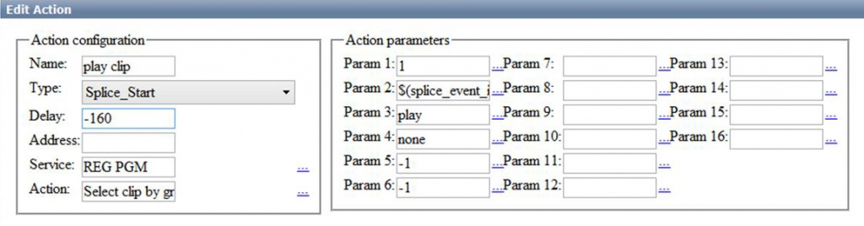
Assigning fields for setting parameters:
Field | Description
Name | The name of the rule in any form (in the example - play clip)
Type | Splice_Start from the drop-down list
Delay
Service | The name of the Program Channel service to be controlled (in the example it is REG PGM) can be selected from the list by clicking …
Action | action when the rule is triggered: Select clip by group - selecting the first clip in the group for playback. The type of action is selected from the dropdown list by the button…
Param 1 | layer number in which the ads will be played: 1 - first full-screen layer
Param 2 | The Splice Event ID value - from the drop-down list
Param 3 | n play command for playback, right after selecting the block by the number sent from the central station
Param 4 | none, if no action is planned when there is no advertising clip
Param 5 | -1
Param 6 | -1

Setting a rule to stop the playlist
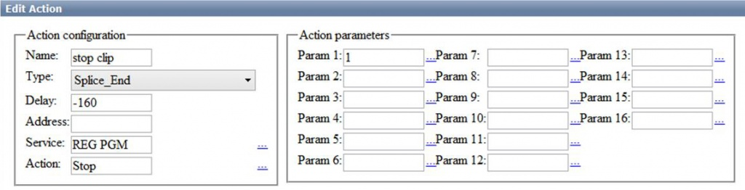|
The second rule is configured similarly to the start tag processing rule:
Field | Description
Name | Name of the rule in any form (in the example, stop clip)
Type | Splice_End from drop-down list
Service | Program Channel service name which is responsible for playlist playback (in the example - REG PGM)
Action | Stop from the drop down list.

Read tags from the pre-recorded and edited central station signal
Working “on the fly” with the input signal from the central station is not the only way the system works. When a delay of the received on-air signal is required, including a variable delay, the SL NEO platform allows you to play a fragment of the prerecorded broadcast in the main full-screen layer (playlist), to detect tags in it, and to insert an advertisement in the first graphical layer, “overlapping” the recorded broadcast.
The Program Channel module is configured from the web control console, menu item - Manage, Program Output tab. You need to select the Actions tab, then - Main Layers Events, then Add Action. Select the type - SCTE-104/35 and press OK. In the new window, similarly to the Capture service settings described above, enter the rule parameters for label analysis and Program Channel module control from the main full-screen layer.

Controlling passing of SCTE tags, viewing information contained in tags
Appearance of SCTE tags in the input stream is indicated by a message in the MESSAGE window of the capture service (opened by right-clicking the icon of the SL NEO server software in the tray).

Example of a message about the appearance of the ad block start mark:
splice_info_section: pid: 500, splice_insert:
splice_insert_type: 1
splice_event_id: 42417000
unique_program_id: 0
pre_roll_time: 7440
break_duration: 0
avail_num: 0
avails_expected: 0
auto_return_flag: 0
Let's look at the details of the message:
- The splice_insert_type: 1 parameter reports that this label is for the start of an ad unit.
- Parameter splice_event_id: 42417000 indicates the group number (ad unit number) to play. A regional playlist must contain an ad unit in the form of a group with the same number. This is the block that will be called for playback by the corresponding command.
- Parameter pre_roll_time: 7440 specifies the delay time set on the transmitting side from the moment the message is received until the advertising block is produced.

Example of an end of commercial block message:
splice_info_section: pid: 500, splice_insert:
splice_insert_type: 3
splice_event_id: 42417000
unique_program_id: 0
pre_roll_time: 7560
break_duration: 0
avail_num: 0
avails_expected: 0
auto_return_flag: 0
Let's look at the details of the message:
- The splice_insert_type: 3 parameter tells you that this is the tag to end the adblock.
- Parameter splice_event_id: 42417000 indicates the group number (ad unit) to be stopped.
- The pre_roll_time: 7560 parameter specifies the delay time set on the sending side from when the message is received until the end of the ad block.

Setting rules for sending commands to the recording service

Handling adblock start tag
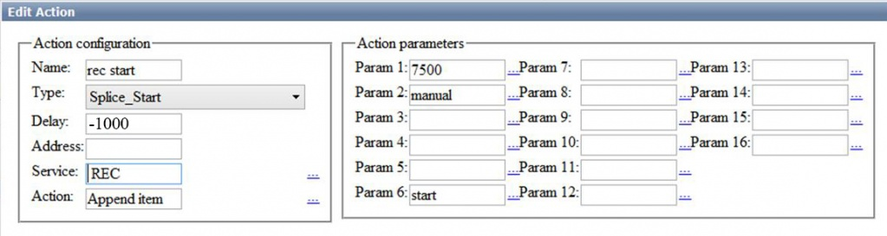|
Field | Description
Name | The free-form name of the rule (rec start in the example)
Type | Splice_Start from drop down list
Delay | -1000 for 1s ahead of the record start time in relation to the regional advertisement insertion time
Service | Name of the recording service in the system that will record the ad unit (in the example it is REC)
Action | Append Item from the drop down list
Param 1 | Recording timing
Param 2 | manual - start type
Param 6 | start - to perform the start of the record in the same command
===Howto:howto:howto:howto:howto:howto:howto
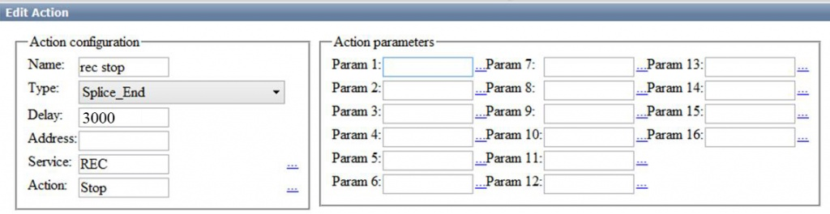|
Field | Description
Name | The name of the rule in any form (in the example: stop)
Type | Splice_End from drop down list
Delay | 3000 to lag the end of the recording by 3s relative to the execution time of the regional advertisement insertion
Service | Name of the recording service that will record the ad block (in the example it is REC)
Action | Stop from dropdown list
To save the settings, click “Apply Changes” at the top of the server console window. This will reload services whose settings have been changed.
.

