Notification of playback of a certain event in the playlist

Task
There are two types of weather messages on the TV channel:
- The WEATHER file is a clip with weather forecast information.
- File WEATHER+DTMF - a clip with information about the weather forecast with additional DTMF tagging for regional punch-in.
It is necessary to provide the possibility of additional control over the output of the file that generates DTMF tags for regional punch-in.

Solution option using AirManager
This option allows you to display a counter for the remaining time until the start of the file playback WEATHER+DTMF in the client application AirManager.
Open AirManager and create a new indicator: AirManager→Window→Display Counters→Add display.
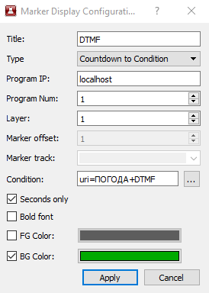
Set the following settings:
Parameter | Value | Description of setting
Title | DTMF | The name of the indicator that will be displayed in the window title
Type | Countdown to Condition | Type of marker. The selected type allows you to display the remaining time until playback of the clip that satisfies the specified condition
Program IP | localhost | The server address where the program channel is located. In our case the multiscreen and program channel are located on the same server.
Program Num | 1 | The serial number of the program channel service within the selected server.
Layer | 1 | The number of the layer where the clip will be searched by condition. 1 is the main playlist.
Condition | uri=WEEK+DTMF | Set condition: MediaId of the clip in the playlist must be equal to WEATHER+DTMF.
Seconds Only | + | Displays the time accurate to seconds. No fractional fractions.
After pressing Apply, an indicator will be created that can be placed at the desired location on the screen.
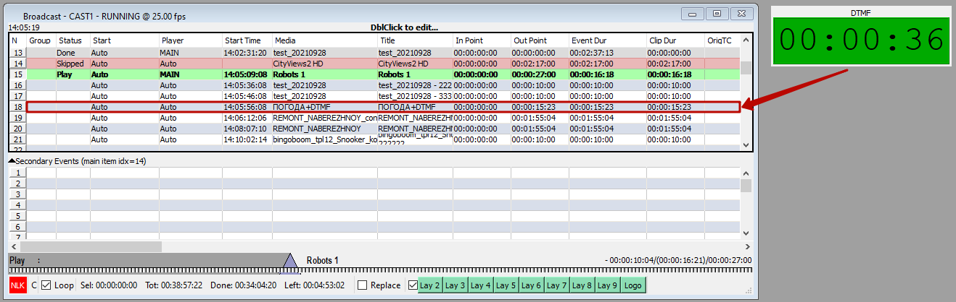

Multiscreen solution option
This option allows you to display an additional message for the on-air operator at times when the program channel is playing the WEATHER+DTMF file. The type of message is determined by the graphic composition that will be displayed in the logo layer of the Playout service used to output the Multiscreen signal.

Preparing graphic compositions
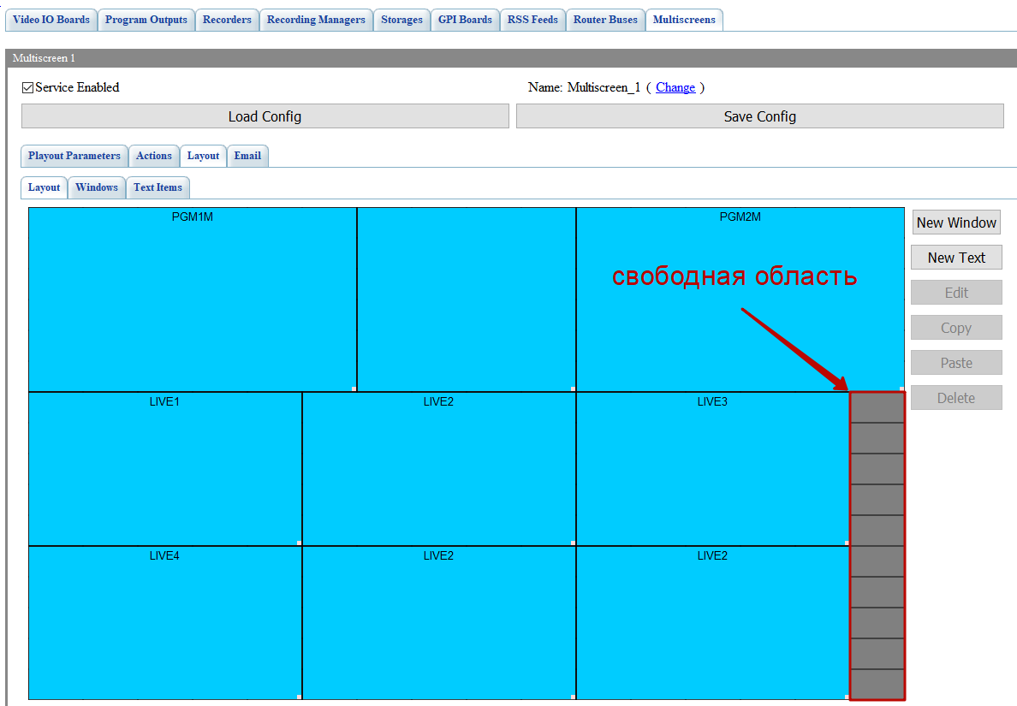
Open the multiscreen settings in the control panel. Determine the free area in the multiscreen layout that you want to use for additional information.
Create a new graphic composition that will display the indicator in the defined area.
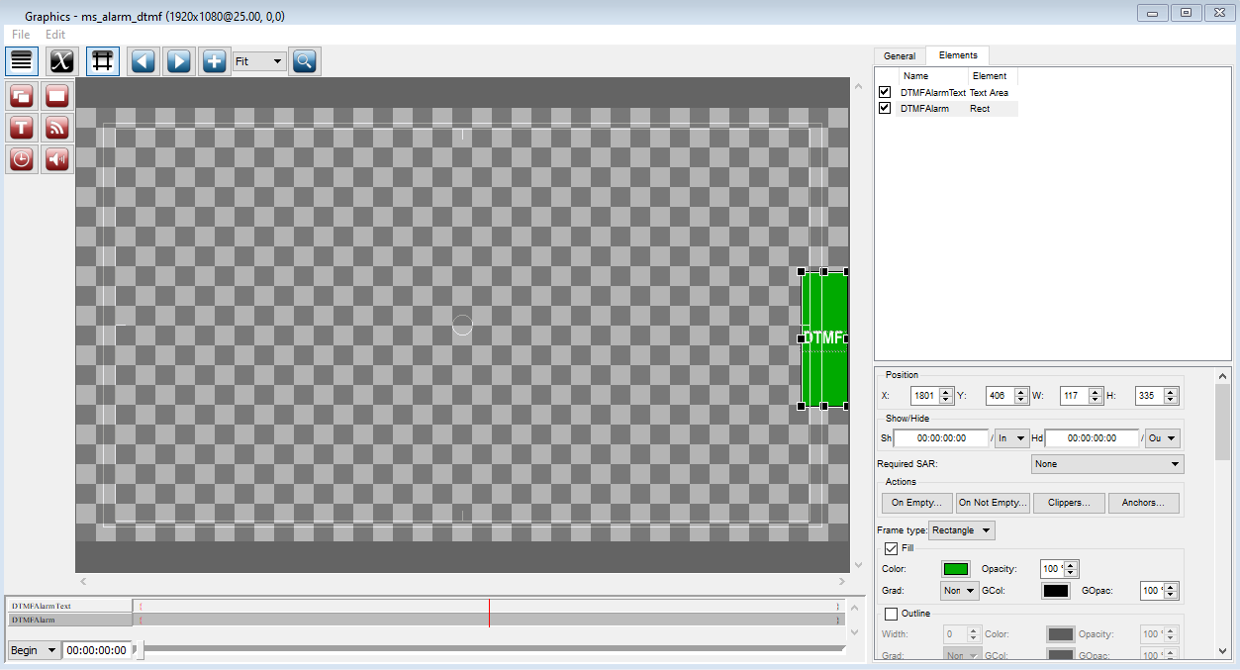
Add a Rectangle Object, which will be the indicator's backing, and a Text Object, which will display text information about the event. Set the color for the Rectangle Object and write the text “DTMF” in the Text Object. Save the composition to a media base named ms_alarm_dtmf.
Right-click on the composition and choose Export… Export the created graphic composition to the file ms_alarm_dtmf.slg.
Create an empty graphic composition without objects, save it to the media base, and export it with the name ms_alarm_empty.slg.
Place the exported slg files in the folder: C:\Program Files (x86)\SL NEO Media Platform\run\files.

Setting up the actions
Go to the program channel action configuration window: Administrator Control Panel→Manager→Program Outputs→Program output N→Actions→Playlist events.
Add a new action, which will display the indicator on the screen.
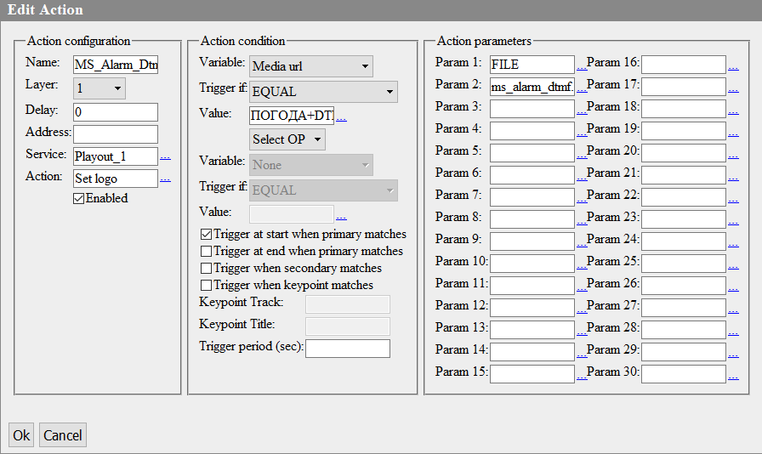
Set the following settings:
Parameter | Value | Description of setting
Name | MS_Alarm_Dtmf | Name of the action that will be displayed in the control panel interface. Try to set clear names for the actions.
Layer | 1 | The layer number of the program channel where the trigger condition will be tracked
Variable | Media url
Trigger if | EQUAL | The condition will be triggered if the value of the Media field is EQUAL to the value from the Value field
Value | WEEK+DTMF
Trigger at start when primary matches | + | This parameter defines the moment of triggering. In this case the Set logo action will be triggered at the moment when playback starts for the event where the condition is triggered (Media=WEEK+DTMF).
Address | localhost | The address of the server hosting the service to which the command will be sent.
Service | Playout_1 | The name of the service used to output the multiscreen signal to which the command will be sent. In our example, the Multiscreen signal is output via Playout_1.
Action | Set logo | Transmit a command to Playout_1 to set a new composition in the logo layer with the Set logo action, which takes 2 parameters.
Param 1 | FILE | The value FILE shows that the clip to be played back should be looked for in the “run/files” folder
Param 2 | ms_alarm_dtmf.slg
Add a new action that will remove the indicator from the screen and replace it with a blank composition.
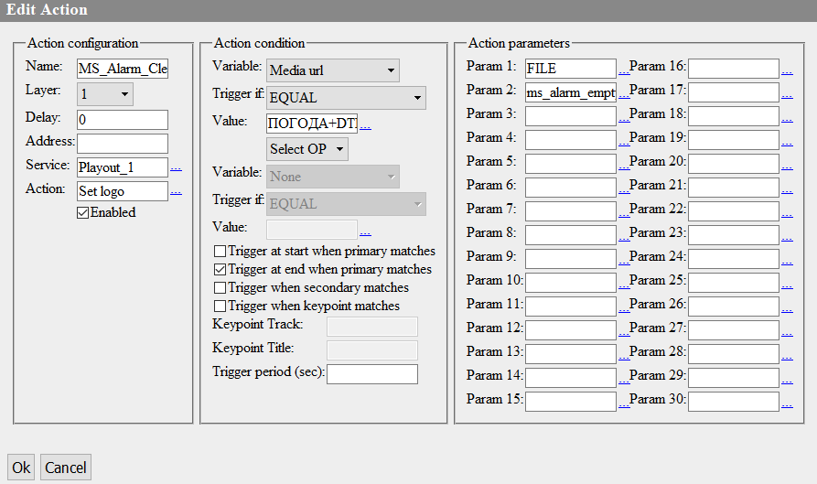
The settings are similar to the previous action, except:
Parameter | Value | Description of setting
Name | MS_Alarm_Clear | The name of the action that will be displayed in the control panel interface. Try to set clear names for the actions.
Trigger at end when primary matches | + | This parameter defines the moment of triggering. In this case the Set logo action will be run at the end of the event when the condition is triggered (Media=WEEK+DTMF). This is necessary to hide the indicator on the screen.
Param 2 | ms_alarm_empty.slg | This parameter specifies the name of the file to be played in the Playout_1 service logo layer. An empty composition will replace the composition with the indicator.

Setting up Playout
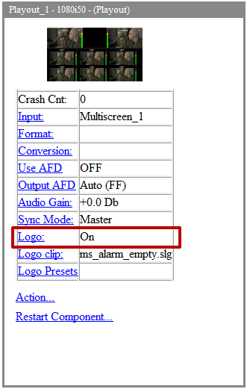
Make sure that the logo layer display is enabled in the Playout service settings on the Status tab.

Result
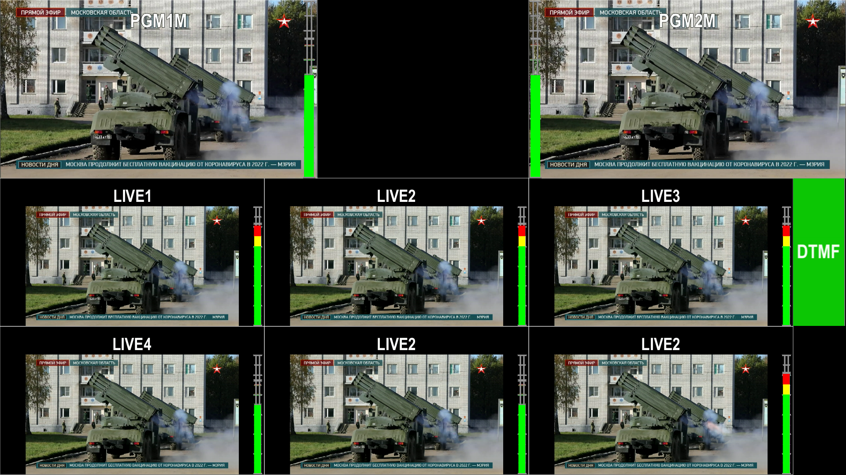
When playing a WEATHER+DTMF clip in a playlist, the corresponding indicator will appear on the multiscreen screen.

Sample Files
Download archive c files:
- ms_alarm_config.xml - multiscreen configuration file with the layout from the example,
- ms_alarm_dtmf.slg - graphic composition with indicator,
- ms_alarm_empty.slg - empty graphic composition.

