Configuring the GPI option (ADLINK PCI/LPCI-7250 series card)
This equipment does not come with the new servers.
This feature is optional and is not active in the standard server feature set. It requires additional hardware and licensing to activate the feature.
.
SL NEO servers work with GPI boards manufactured by ADLINK (PCI/LPCI-7250 series, contains 8 inputs and eight relay outputs). The procedure of GPI option installation and configuration is as follows:
- Install the GPI board in a free slot in the server system unit (PCI or PCIe, depending on the ADLINK board model). Install drivers and PCIS-DASK software (supplied with the board).
- Select Configure Server Hardware item on the SL NEO Mediaserver icon in the tray (server software must be pre-stopped by the Stop Server command). In the settings window from the Available components field add the PCI-7250 item to the right side.
- Start server software (right click on SL NEO Mediaserver icon in your system tray).
Further settings will be made from the control panel - Administrator Control Panel. Logging into the management console is done locally from the server or from any machine in the network at http://ip_address:7901. You should log into the management console as an administrator. After logging into the management console: in the left menu of the console select Manage, then select the GPI Boards tab, in the GPI Board 1 window select Service Enable.
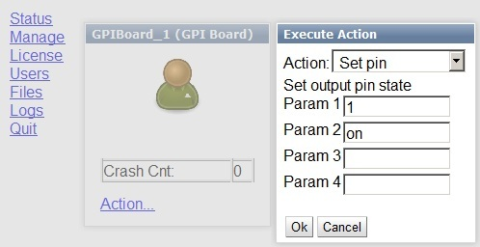
You can check if the board is operational in the Status item in the left menu of the server management console. In the GPI Board_1 window, select Action - Set Pin, select the board output number (1) in the Param 1 field, and select the ON command in the Param 2 field. When you press OK, relay 1 will turn on.
Now, after checking the operability, you must create a rule (Action) to set up any specific action.

Example: configuring rules for GPI control of an external hardware logo generator from the playlist column
The procedure is performed from the web-console, menu item Manage, tab Program Outputs. In the selected playback channel, find the Actions tab, then the Playlist events tab and select Add Action. In the window that opens, specify the parameters of the new rule to control the external log generator from the playlist column.
In the Action Configuration window specify the rule name in the Name field, select 1 (main full-screen layer) in the Layer field, specify server IP address in the Address field or leave the field blank if localhost is specified. In the Service field click the button… Select the name of the service to be managed from the list. In our example, it is the GPI board control service (GPI Board_1 in the list).
In the Action condition window in the Vairable column of the playlist which will be responsible for turning on the logo, for example, the GPI Board 1 column, set the trigger to EQUAL and in the Value field write on.
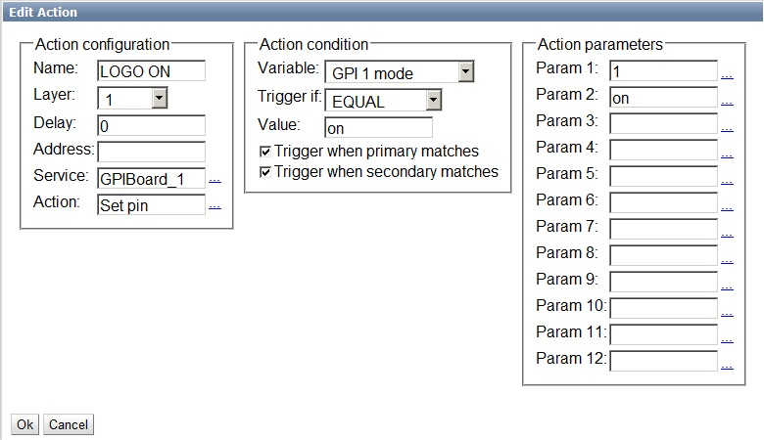
Next, use the same scheme to create a rule to turn off the logo.
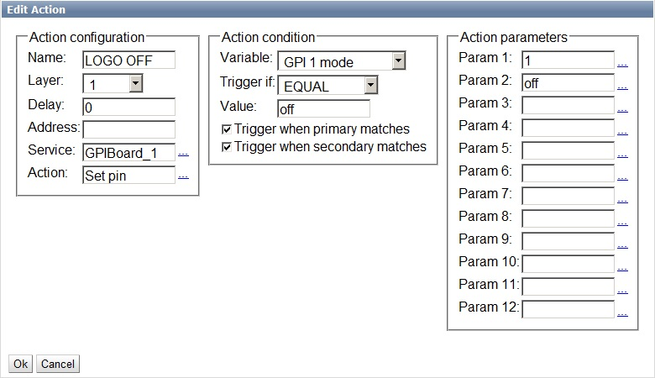
There are now 2 new rules in the Actions tab.
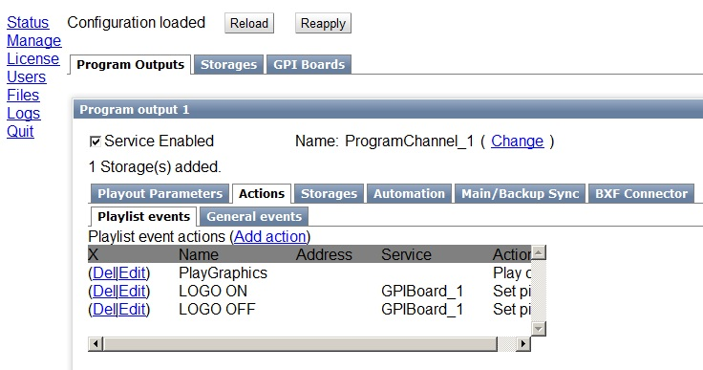
To save the settings, click Apply Changes at the top of the control console window. In this case, the playback channel whose configuration was changed will be reloaded, playback on that channel will be paused at the moment of reloading.
Now the control of enabling/disabling the external hardware loginserter will be performed from the GPI 1 column of the playlist.

