Where do I start with the server?
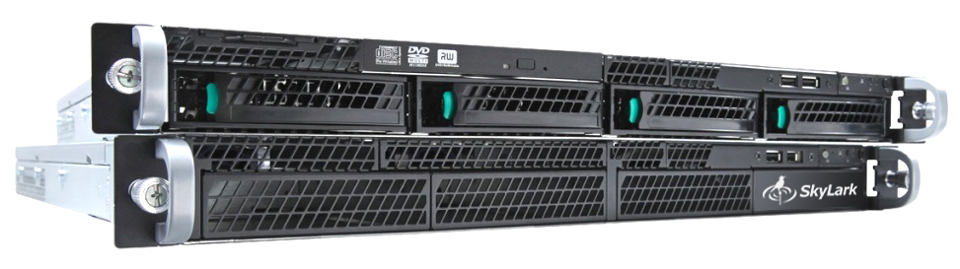
Rack mounting may require 1 to 6 RU (depending on server model and configuration) of vertical rack space. If possible, allow 1 RU of free space above and below the server system unit. Install the SL NEO server system unit in the equipment rack, ensuring proper temperature and ventilation.

Connect I/O signals
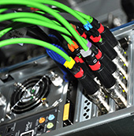
On the back of the server system unit are the I/O board connectors. You can connect to the BNC/XLR connectors, via jumpers, or via a patch/trem panel, depending on the type of I/O board and the configuration of your server. Connect the analog black box signal from a tested and quality source for SD configurations or Tri Level Sync signal for HD configurations to the corresponding input of the system unit. Make sure that the frame and line sync frequencies are selected correctly, and when connecting devices in series, make sure that the pass-through signal output on the last device is muted by the terminator.

Power On Procedure
Ensure that the network cables are connected to all power supply modules in the SL NEO server system unit. Also make sure that power is being supplied to all cables.
Press the power button on the front of the server. After the power is turned on, the BIOS and operating system will start to boot up. If the server is paired with an external disk array, power up the array first, then after 20-30 seconds power up the server.

Starting server software
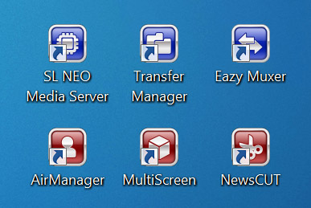
The SL NEO servers come pre-installed and activated software, fully configured and ready to go.
The Windows login password is 12345, or no password, for Windows 2008R2 is QWE123qwe. Set a new password immediately after installing the server at the site of operation!
After powering up and booting the operating system, the server software module must be started. The corresponding icon “SL NEO Media Server” is located on the Windows desktop.
After starting the server software loader, the SkyLark Neovid loader icon will appear in the Windows taskbar, reflecting the activity of the SL NEO server software. If the icon is red, it means that the software bootloader is running, but all server software modules are stopped. A blue icon means that the server software modules are functioning.
Right-clicking the SkyLark Neovid icon brings up a menu that starts and stops the server software modules.

Main commands of the menu
- Start Server - launches the SL NEO software server modules that are preconfigured and configured.
- Stop Server - stop the SL NEO software server modules.
- Administrator Control Panel - web-console for server management. It is started when the server software is running.
After starting the server software you can start client applications on the server itself and on client stations (the main client control module - Air Manager).
On the server itself there is also a complete set of client software that allows controlling all the server functions, but in normal operation mode it is recommended to use remote control from network workstations. This is connected with additional load on server CPU by client software and with the fact that built-in video card of server mother board has low productivity and is not intended for full-fledged video display.
The USB flash-drive included with the server contains: drivers, files with default settings, software installation kits, a full set of documentation in PDF format. System disk image is located on the RAID-array of the server.

Important!
It is not recommended to update the BIOS, device drivers and install operating system updates without special necessity and without the manufacturer's consent.
Remember that after the BIOS update the serviceability of the server platform is not guaranteed, moreover the valid license for SL NEO software will become inactive.
Reinstalling Windows OS from scratch will also make the license key inactive. In order to create a backup of information from the system disk, you should create an “image” of the system using Acronis software, for example. After restoring the system from the “image”, all settings will be restored, and the license key will also be active.
After changing the IP address of the server, as well as after disconnecting/connecting the Ethernet network connection, you should restart the server software SL NEO.
CPU capacity of all delivered SL NEO servers is calculated and selected based on the ordered configuration: number, types and formats of input/output channels, with certain reserve. If you change the configuration by yourself, change the settings of recording and playback channels, change formats of SD - HD, change the codec to H.264 for recording or IP-streaming, control the load on the processors of the server platform, not allowing to exceed the load index of 80-85%.
When configuring a large number of streams/rules for Transfer Manager, the CPU load on the server can also reach 100%, which in its turn negatively affects the recording and playback operations: freeze frames appear during playback and skipped frames appear during recording. To avoid such situations, you need to control CPU load at the level of 80-85% when you change Transfer Manager settings and especially after adding new rules. If you work in HD mode and you need to perform 4 (conditional) or more parallel streams of moving media files with transcoding, you need to allocate a separate computing platform for Transfer Manager.
Do not install anti-virus software on the server platform. While working, periodically, the activity of antivirus software leads to a noticeable increase of load on the server CPU; deep integration of this software into the operating system does not allow it to affect its work in any way.
In cases of doubt, in case of malfunction, contact us for advice and support. Free technical support by phone and e-mail is available during working days and hours for all users of SkyLark Technology products.

