Configuring the basic components of the server platform
Important: Settings of the server platform must be made by qualified specialists who have been trained and have the appropriate credentials. Keep in mind that unqualified actions may affect the performance of the server platform, adding new components may invalidate the current license. Contact support for more details!
.
Configure Server Components - configuration console for basic hardware and software components of the SL NEO server. The console allows you to form a “set” of hardware nodes and server software modules - specify the models and number of I/O boards, the number of recording/playback channels of the server.
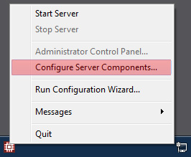
The procedure for selecting base modules is done when the server is assembled by the manufacturer, according to the ordered configuration, however, this procedure will be described below.
Before starting the configuration process, make sure that all necessary devices and device drivers for the server hardware components (I/O cards, control ports), are installed and functioning properly.
The console is started when the SL NEO server software is stopped (after executing the Stop Server command by right-clicking the red SkyLark NeoVid bootloader icon in the Windows taskbar). The settings are made through a dialog box containing 2 main windows Available components and Installed Components.
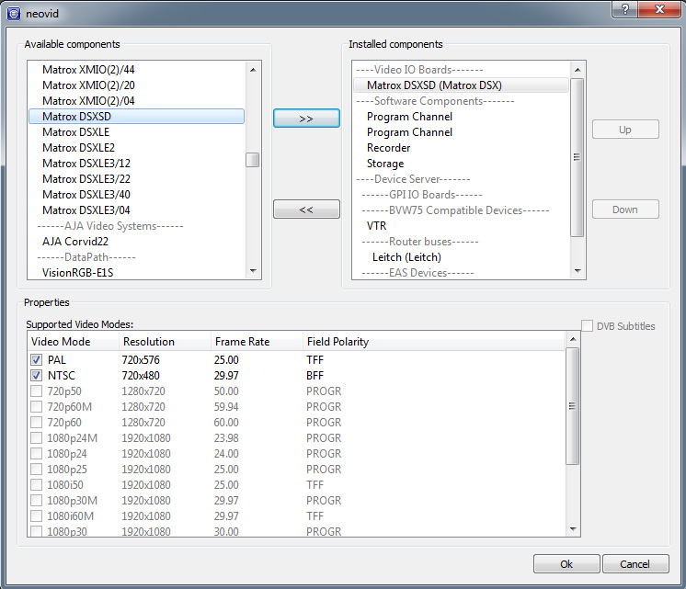
Available components - the window contains the list of all supported hardware devices and basic server software modules (within the current SL NEO software version). The main elements and sections:
Section | Description
Video IO Boards | section contains the list of supported I/O boards.
LAN Interfaces | is an interface for recording/playback using IP technologies (UDP/RTP protocols).
FireWire | Interfaces is an interface for recording/playback via IEEE1394 (DV25/HDV).
Computer Screen | Interface for organizing a playback channel using the server's built-in VGA adapter.
Software components | basic server software modules of the SL NEO platform.
Program Channel | module of automated playlist execution for one channel (service SL NEO Program Player).
Recorder | single channel recorder module.
Time Shift | module that performs time delay functions from 3 minutes to several hours, with recording on disks.
Storage | SL NEO Media Database is a server module that performs the function of a specialized database.
RSS Feeder | is a RSS server module, which receives information from text/xml files and displays it as a local RSS resource. It is used for graphic design of on-air programs.
Instant Replay | Module for the slow motion system, used in conjunction with the recorders in the 7000 series servers.
Profanity Delay | a module that performs the functions of a “short” time delay from 1 to 30 seconds, with recording in RAM.
Device Server | is an integrated device server of the SL NEO platform (with partitions according to the type of supported devices).
GPI IO Boards | a list of supported control boards with GPI I/O interface.
BVW75 | VTR device with RS port control by Sony 9-pin protocol (used in recording).
Router Buses | a list of matrix switch models (controlling them is relevant for software switching and recording).
Data Providers | Internal RSS server, similar in functionality to the module RSS Feeder, but in contrast to it interacts not with the files, but with the devices.
Meteo Stations | list of weather station models.
To select the necessary element, you need to select it in the Available components window and press the » button to move it to the Installed Components window. To delete an item in the Installed Components window, press the « button.
The Installed Components window contains a list of hardware and software components for this server. The Properties window displays the list of available modes for a selected device or program module in the Installed Components window. The Proerties window allows you to disable video modes for selected hardware modules.
**At this stage the SL NEO server configuration consists of selecting the necessary basic hardware and software components that will form the base of the configuration.

Example of SL NEO server configuration
Let's consider the configuration process on the example: there is Matrox DSX.SD card in the server that provides simultaneous independent functioning of 2 playback channels and one recording channel in SD mode. The task: to set up a server with 2 playback channels and 1 recording channel, with the option to digitize material from VTR and with matrix switch control for software switching of 2 channels.
Step 1: In the Available Components window in the Video IO Boards section select Matrox DSX.SD board and move it to the Installed Components window with arrow ». The list of modes available for Matrox DSX.SD is displayed in the Properties window.
Step 2: In the Available Components window, select the Program Channel element. This is a module that includes the SL NEO Program Player service (automated playlist execution module for one channel). Use arrow » to move Program Channel to the Installed Components window. This operation should be done twice, because we plan to install two independent playback channels.
An additional Layers window is displayed to the left of the Properties window for the Program Channel module. The type and number of graphic layers are set there. Activating Main Layer means that a full screen layer will be used (this layer is not used when the server generates FILL+KEY). The Graphics Layers parameter value indicates the number of graphic layers (playlists) for a given server playback channel (4 by default, maximal value is 8).
Step 3: In the Available Components window select Recorder. Use arrow » to move Recorder to the Installed Components window. You have to do this once, as we are planning to install only one channel for recording, it is restricted by the Matrox card installed in the system.
Step 4: Selecting the required software components. In the Available Components window select Storage - SL NEO Media Database - the server module, which serves as a specialized database. Use the » arrow to move Storage to the Installed Components window.
Step 5: As an option, select VTR for batch digitizing when recording. In the Available Components window, select VTR - server module, control VTR via RS-422 by Sony 9-pin remote protocol. Use arrow » to move VTR to the Installed Components window.
Step 6: Add a matrix switch to the system. In the Available Components window in the Router buses section, select, for example, Leitch. Use arrow » to move Leitch to the Installed Components window.
At this point, the configuration of basic hardware and software components of the server is complete.
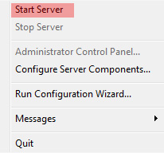
Then you should press OK and exit the configuration window, then run the Start Server command - launch the SL NEO software server modules by right-clicking on the SkyLark NeoVid icon in the Windows taskbar or on the SL NEO Media Server icon on the desktop.

