Replacing the standard DSP when starting the Program Channel service
During software startup, the output of the Program Channel module outputs a standard DSP. This is due to the fact that it takes less time to prepare the image output system than to initialize the playlists in the program channel.
Under certain circumstances, this image may be output on the air, so a neutral image or a branded stub corresponding to the corporate style may be required.

Standard file
The system uses the following path to the stub file: C:\Program Files (x86)\SL NEO Media Platform\docroot\bars.png.
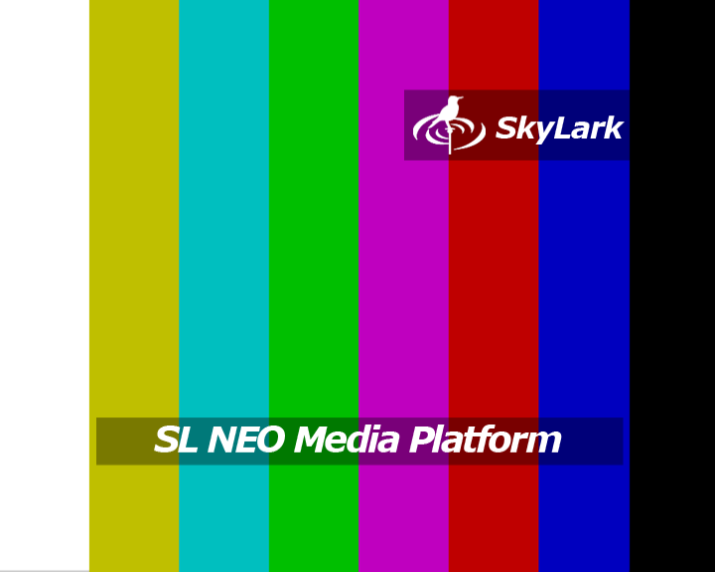
The default bars.png file has a resolution of 720×576 with an aspect ratio of 4×3.

Replace file
Please note that the stub image is applied to all program channels within one server. Installation of individual images for each program channel is not supported.
.
As a muffler it is allowed to use a static image in PNG format with a resolution corresponding to the format of the program channel or smaller. The image may be scaled when output.
Replace the bars.png file in the C:\Program Files (x86)\SL NEO Media Platform\docroot\ folder with your own.
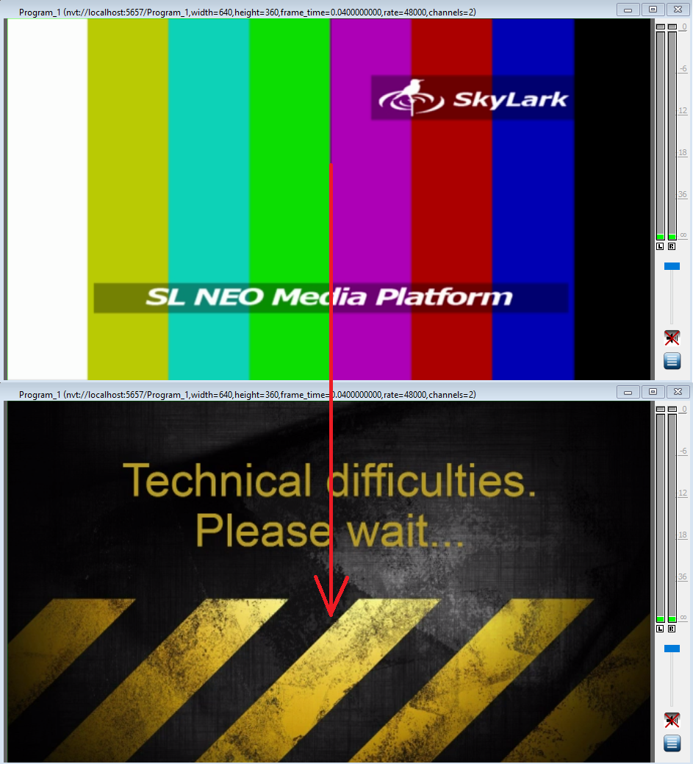
The next time you run the software, your file will play.

Downloads
- Example custom file howto:bars_custom.png

