Boards
Skylark SL NEO software supports I/O boards from different manufacturers.

Connectors
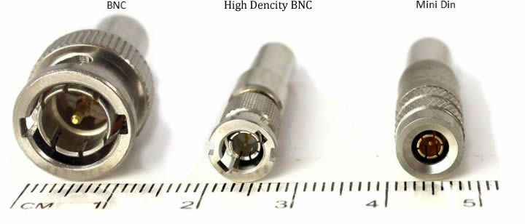
Connector | Fits Boards
BNC | Matrox DSX.sd, Matrox DSX LE3, StreamLabs MH4LM, Dektec DTA-2160, Blackmagic Decklink Duo/Duo2, DeckLink SDI 4K, DeckLink 4K Extreme 12G, DeckLink Mini Monitor, DeckLink Mini Recorder
Mini BNC HD | Matrox DSX LE4
Mini DIN | Blackmagic Decklink Quad/Quad2

SDI Interface
Speeds and supported formats
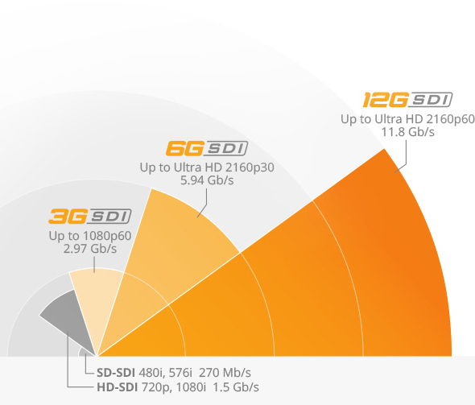

Matrox
The most reliable and trusted boards for stable solutions.
General information about the Matrox product line is available at the official website.

Matrox DSX LE4 LP
These boards are equipped with Mini BNC HD Female Connector 75 ohm sockets. The Mini BNC HD → Regular BNC cable connectors are not included to the standard server delivery set and must be ordered separately.

Description
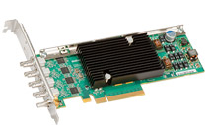
Matrox DSX LE4 LP is a low-profile, half-length PCIe card that offers up to eight reconfigurable SDI I/Os—from SD to 4K. When configured with inputs, the cards are equipped with built-in frame synchronizers to generate clean SDI signals in any environment.
Matrox DSX LE4 LP Matrox DSX LE4 LP is ideal for OEMs who need to create compact channel-in-a-box systems, video servers, broadcast graphics systems, encoders, transcoders, multiviewers, switchers and other digital media equipment.
- low profile boards with the possibility of installation to the 2U chassis without risers;
- configurable inputs/outputs, 4 or 8 channels (depending on the board model), SD/HD/3G SDI with embedded sound.
- selecting the format (SD/HD) individually for every server channel;
- frame synchronizers by inputs, stable work of capture channels in case of disappearing input signals.
- VANC and HANC support for every input and output;
- The REF analogue signal input (bi-level or tri-level sync);
- automatic relay balance (the option is available in certain board models);
- Live zero-frame delay video mixers

Drivers
Matrox DSX LE4 LP boards require drivers of the version 9.5-b3 and higher. Download the device driver

Ports Positioning
The board contains from 5 to 9 ports with mini BNC Female sockets. The current Input/Output configuration for the board is displayed in the Matrox X.Info utility or in the mvConnectorConfig.exe command line utility (see Ports Configuration).
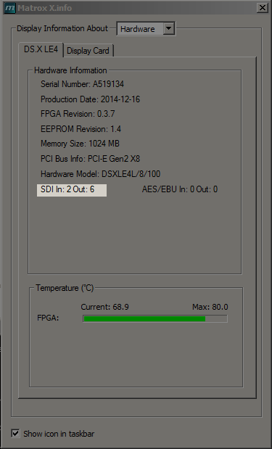
Numeration of ports on the Matrox DSX LE4 LP board starts from the motherboard.
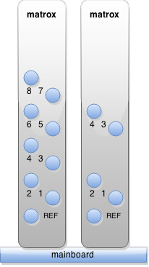
DSX LE4 LP connections for relay-enabled cards
DSX LE4 LP Model | Port Number | Channel
/22 model | 4 | OUT D / Key B
/22 model | 3 | IN C / Key A
/22 model | 2 | OUT B
/22 model | 1 | IN A
DSX LE4 LP Model | Port Number | Channel
/44 model | 8 | OUT H / Key D
/44 model | 7 | IN G / Key C
/44 model | 6 | OUT F / Key B
/44 model | 5 | IN E / Key A
/44 model | 4 | OUT D
/44 model | 3 | IN C
/44 model | 2 | OUT B
/44 model | 1 | IN A
DSX LE4 LP connections for reconfigurable cards
DSX LE4 LP Model | Port Number | 40 | 31 | 22 | 13 | 04
/4 model | 4 | IN D / Key B | OUT D | OUT D / Key B | OUT D / Key B | OUT D / Key B
/4 model | 3 | IN C / Key A | IN C / Key A | IN C / Key A | OUT C | OUT C/ Key A
/4 model | 2 | IN B | IN B | OUT B | OUT B | OUT B
/4 model | 1 | IN A | IN A | IN A | IN A | OUT A
DSX LE4 LP Model | Port Number | 08 | 17 | 26 | 35 | 44 | 53 | 62 | 71 | 80
/8 model | 8 | OUT H / Key D | OUT H / Key D | OUT H / Key D | OUT H / Key D | OUT H / Key D | OUT H / Key D | OUT H / Key D | OUT H | IN H / Key D
/8 model | 7 | OUT G / Key C | OUT G / Key C | OUT G / Key C | OUT G | IN G / Key C | IN G / Key C | IN G / Key C | IN G / Key C | IN G / Key C
/8 model | 6 | OUT F / Key B | OUT F / Key B | OUT F / Key B | OUT F / Key B | OUT F / Key B | OUT F | IN F / Key B | IN F/ Key B | IN F/ Key B
/8 model | 5 | OUT E / Key A | OUT E | IN E / Key A | IN E / Key A | IN E / Key A | IN E / Key A | IN E / Key A | IN E / Key A | IN E / Key A
/8 model | 4 | OUT D | OUT D | OUT D | OUT D | OUT D | OUT D | OUT D | IN D | IN D
/8 model | 3 | OUT C | OUT C | OUT C | IN C | IN C | IN C | IN C | IN C | IN C
/8 model | 2 | OUT B | OUT B | OUT B | OUT B | OUT B | IN B | IN B | IN B | IN B
/8 model | 1 | OUT A | IN A | IN A | IN A | IN A | IN A | IN A | IN A | IN A

Ports Configuration
Ports configuration of the reconfigurable Matrox DSX LE4 LP board is implemented by the mvConnectorConfig.exe utility, which is a part of the Matrox driver batch. The program is launched in the Windows command line.
C:\Program Files\Matrox DSX.utils\drivers>mvConnectorConfig.exe
<< Matrox Connectors Configuration tool >> Tuesday, May 26, 2015 15:11:58
Usage:
- ./mvConnectorConfig.exe list | ShowCurrent | -XinYout [command options]
- ./mvConnectorConfig.exe list : Displays the list of boards installed in the system
- ./mvConnectorConfig.exe ShowCurrent [-hw=hardware_index] : Displays the current I/O configuration for the selected board
- ./mvConnectorConfig.exe -XinYout [-hw=hardware_index] : Changes the I/O configuration for the selected board
Options:
- -hw=hardware_index : The device selected for an update is identified by the index (the first board in the system has the index=0), which is displayed by the “list” command. If hardware_index is not specified, the parameter is equal zero.
- -XinYout : The I/O configuration of the installed board, where X is the number of inputs, and Y – the number of outputs.
An example of viewing the list of boards installed in the system:
./mvConnectorConfig.exe list:
Available hardware:
0) DSXLE4 S/N=A519134
An example of the board configuration with 2 inputs and 8 outputs. ./mvConnectorConfig.exe -2in6out
After configuration is completed, the system must be reloaded.

Matrox DSX LE3
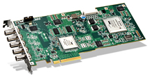
Matrox DSX LE3 family of PCIe cards offers cost effective multi-channel 3G/HD/SD SDI I/O hardware for ingest, playout, and live production solutions. All SDI inputs and outputs are independent and provide support for embedded audio and ancillary data. The ¾ length cards feature BNC connectors to simplify wiring.
Key features
- ¾ length PCIe x 8 board
- Standard BNCs on bracket
- Up to four 3G/HD/SD SDI inputs
- Up to four 3G/HD/SD SDI outputs
- Hanc and vanc support
- Live video mixers
- Up to 4K QFHD resolution at 60 fps

Modifications
Board | Inputs | Outputs | Ports Positioning
DSXLE3 12 | 1 | 1+1Key or 2 (since 2.0.185) | Mainboard: OutKey/Out/In/REF
DSXLE3 22 | 2 | 2 | Mainboard: Out2/Out1/In2/In1/REF
DSXLE3 40 | 4 |  | Mainboard: In4/In3/In2/In1/REF
DSXLE3 04 |  | 4 | Mainboard: Out4/Out3/Out2/Out1/REF

Compatibility
Matrox DSX LE3 drivers are not always loaded correctly in Windows 10 via cold boot, if the hibernation mode is on. Turning off the hibernation mode solves this issue:
- Open the command line interpreter (CMD).
- Execute the command powercfg.exe /h off.
- Reload the server.

Matrox DSX.sd
Discontinued. This equipment is not supplied with new servers.
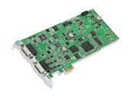
Matrox DSX.sd offers multi-channel SD analog and digital video and audio I/O capabilities.
Key features
- Standard-length PCIe x1 card
- NTSC and PAL
- One SDI input
- Two SDI video outputs or one video / key
- One Y/C or component or CVBS input
- Two analog outputs - Y/C or component or CVBS plus CVBS or key
- 2-in/4-out unbalanced AES/EBU audio channels
- 2-in/4-out balanced analog audio channels
- Eight SDI embedded audio I/O channels
- VBI support
Pinout of Matrox DSX.SD board sockets

Blackmagic Design
General information about the Blackmagic Design product line can be found at the official website.

DeckLink Mini Monitor
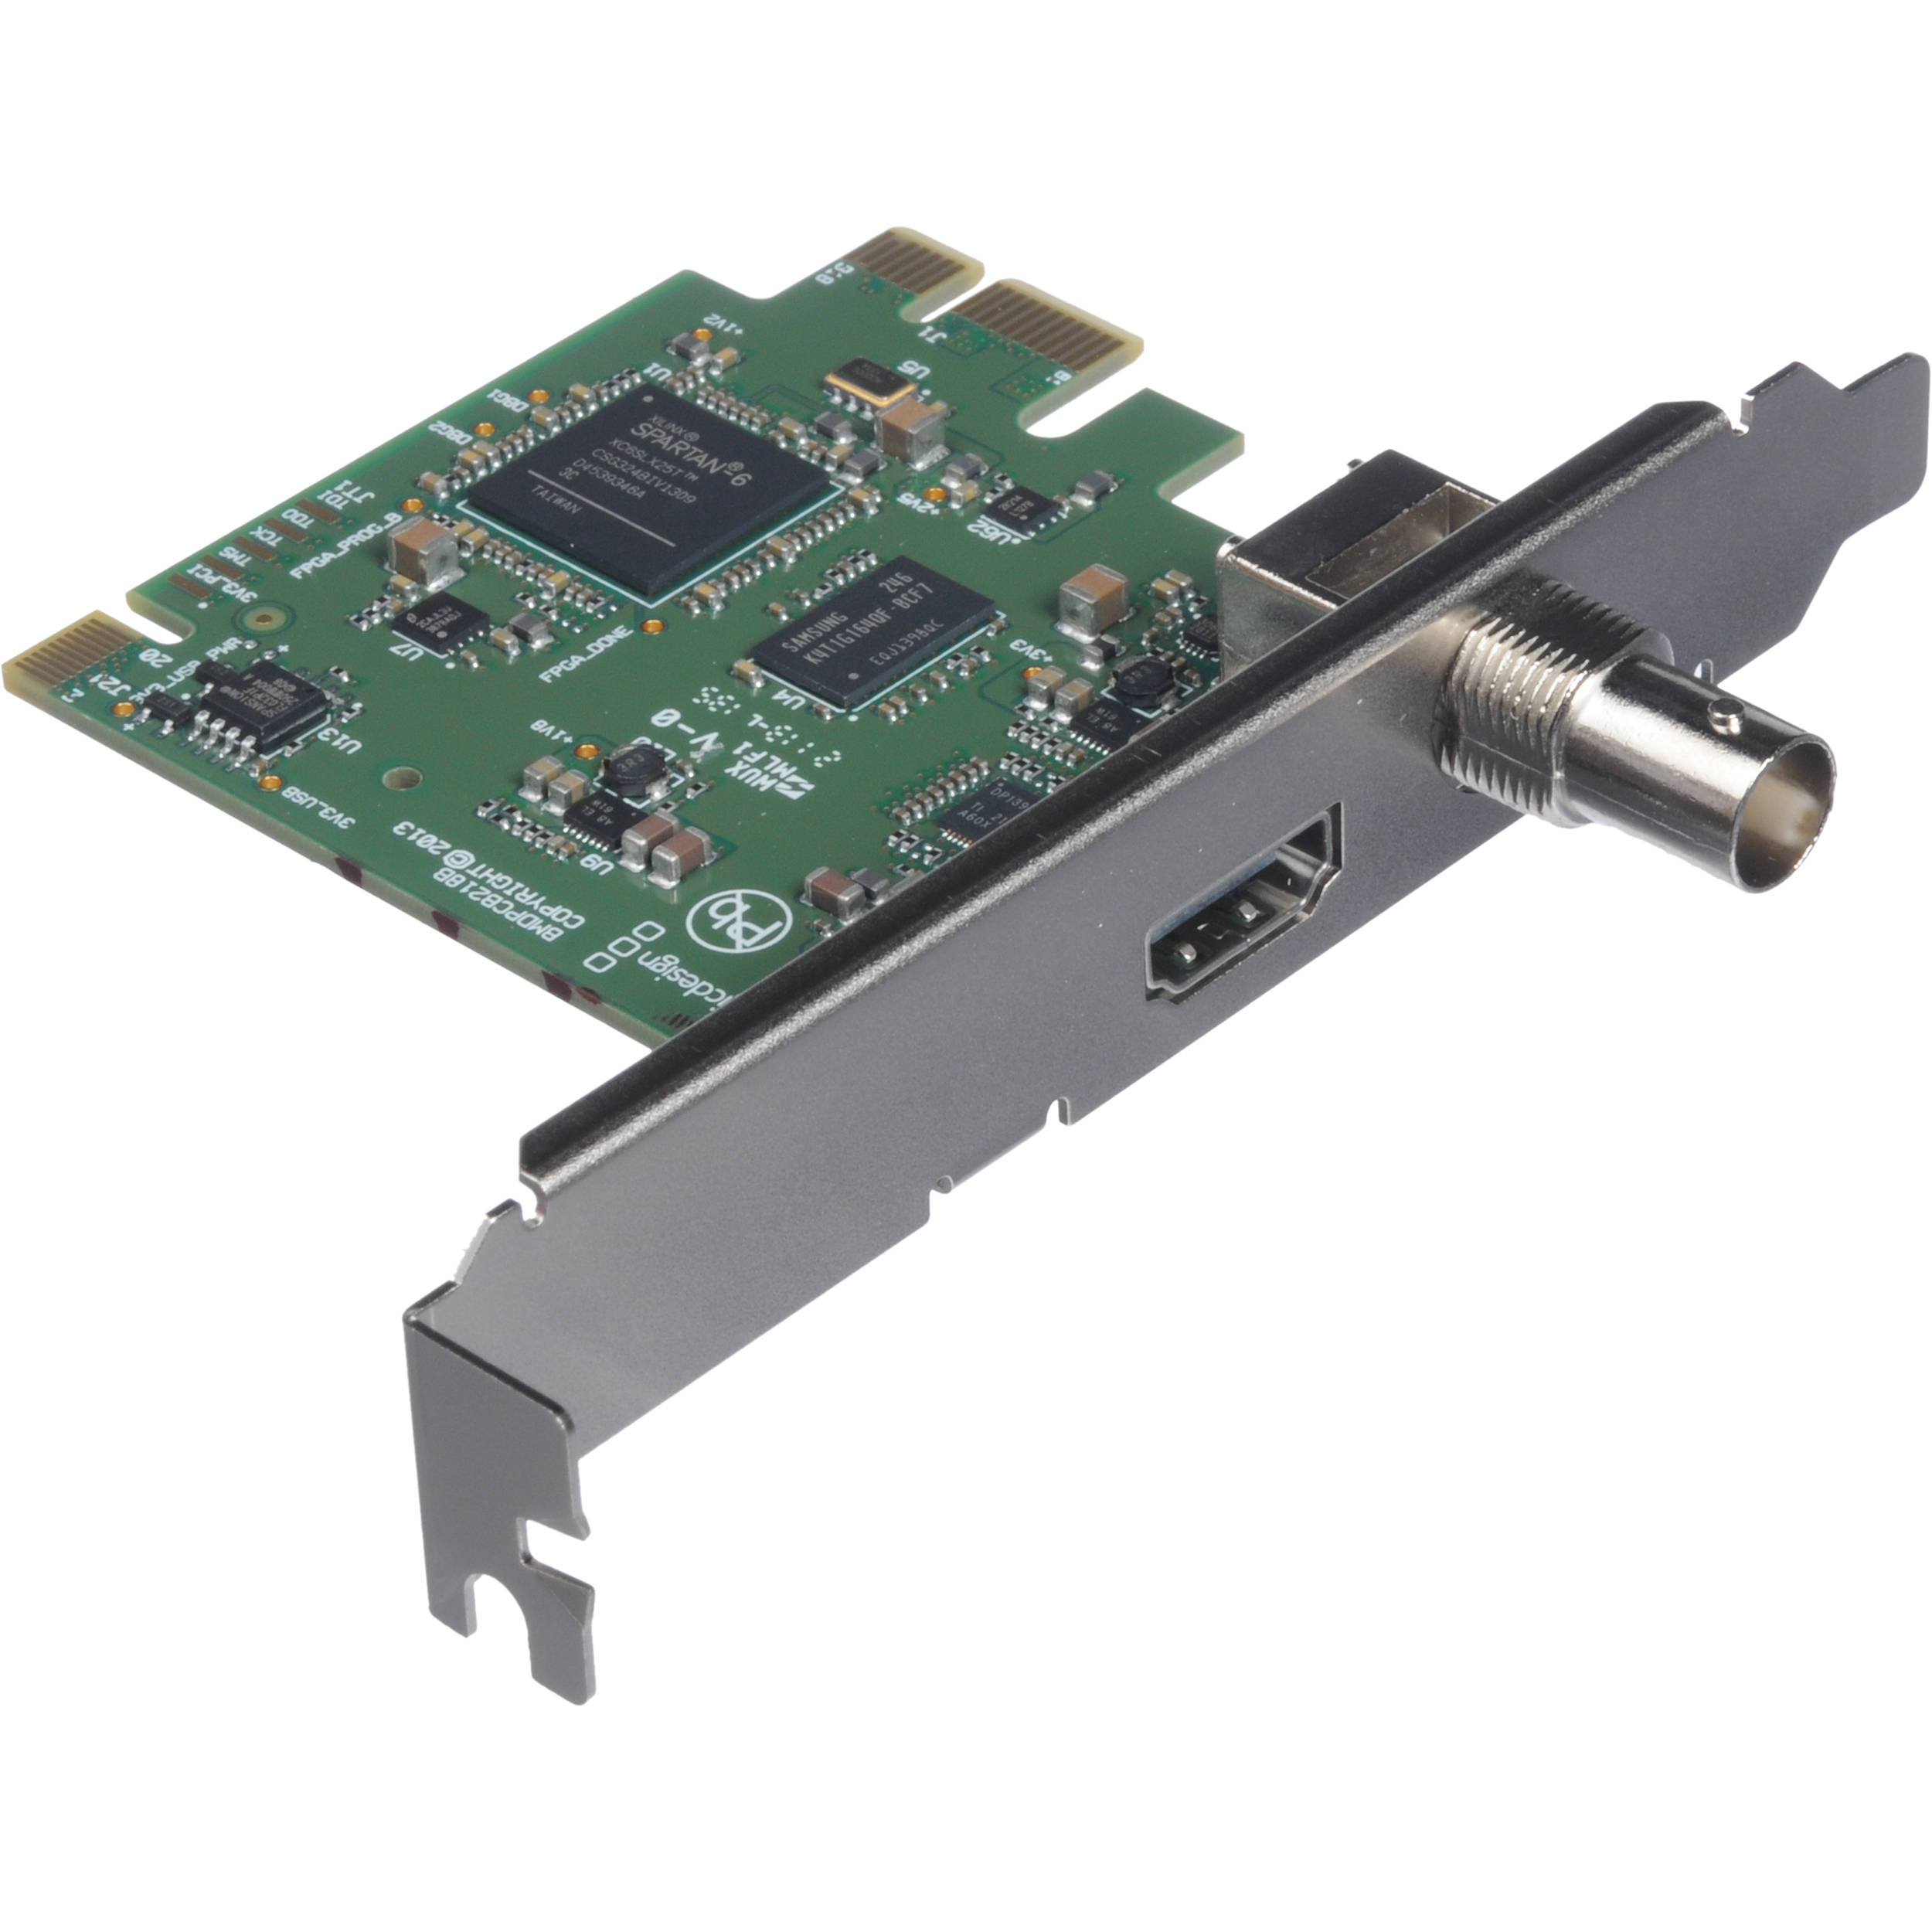
The board has 3G-SDI and HDMI outputs for connecting any TV or monitor. Blackmagic DeckLink Mini Monitor automatically switches between SD and HD, supporting all traditional formats. The set includes two PCI attachments: for full-size and low-profile sockets.
ID: BDLKMINIMON

DeckLink Mini Recorder
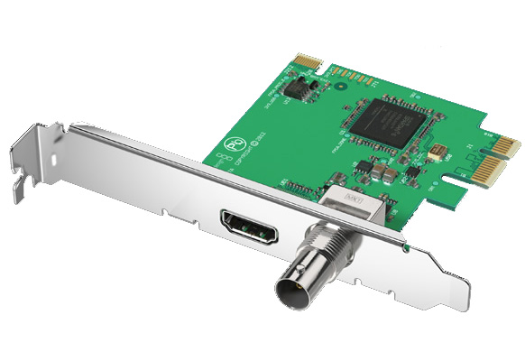
Blackmagic DeckLink Mini Recorder switches between SD and HD formats and is great for building capture servers and any other video-solutions that require low-profile video-capturing boards. The set includes PCI attachments both for full-size and low-profile sockets.
ID: BDLKMINIREC

DeckLink Mini Monitor 4K
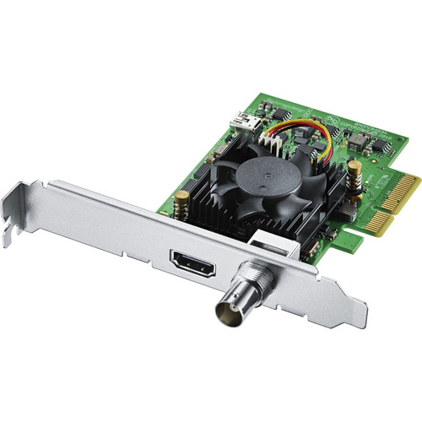
The DeckLink Mini Monitor 4K board allows working with any kind of SD, HD and Ultra HD up to 2160p/30. This is a 4-linear 2nd generation PCI Express board with 6G-SDI and HDMI 2.0a interfaces. Such sockets provide transmitting a high quality YUV 10 bit and RGB 12 bit signal. The board is supplied with two PCIe screens for installing to both full-size and low-profile slots.
Board support is added in 2.3.97 version.
ID: BDLKMINIMON4K

DeckLink Mini Recorder 4K
The DeckLink Mini Recorder 4K board allows working with any kind of SD, HD and Ultra HD up to 2160p/30. This is a 4-linear 2nd generation PCI Express board with 6G-SDI and HDMI 2.0a interfaces. Such sockets provide transmitting a high quality YUV 10 bit and RGB 12 bit signal. The board is supplied with two PCIe screens for installing to both full-size and low-profile slots.
Board support is added in 2.3.97 version.
ID: BDLKMINIREC4K

DeckLink Quad
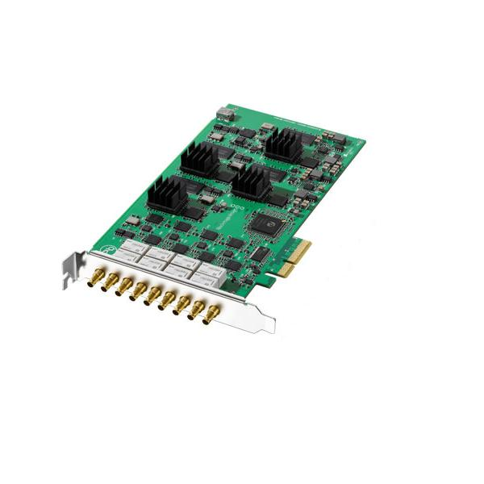
The DeckLink Quad model based on the PCI Express interface type contains 4 independent video-capturing DeckLink boards. Each board is supplied with a bypass-scheme and a special control timer and allows recording and playback of video-materials in a special native non-compressed (8 and 10 bit) SD/HD format with YUV 4:2:2 color resolution.
- Supported SD formats: 625/25 PAL, 525/23.98 NTSC and 525/29.97 NTSC;
- Supported HD formats: 720p50, 720p59.94, 720p60, 1080PsF23.98, 1080p23.98, 1080PsF24, 1080p24, 1080PsF25, 1080p25, 1080PsF29.97, 1080p29.97, 1080PsF30, 1080p30, 1080i50, 1080i59.94 and 1080i60;
- Synchro-input characteristics: Blackburst synchronization in 720p59.94, SD, 720p50, 1080i50 and 1080i59.94 formats; Tri-Sync synchronization in any HD format.
The board does not support VANC processing.

Ports Positioning
The board contains 9 ports (8 switchable ones). Only one connector in a pair can be functioning at a time (except the bypass mode), which allows configuring 4 independent channels on one board.
BNC (socket numeration from the motherboard) | Designation | Comparison to Capture services | Comparison to Playout services
1 | REF | Genlock_1 | Genlock_1
1 channel
2 | SDI In 1 | Capture_1 | no*
3 | SDI Out 1 | no | Playout_1
2 channel
4 | SDI In 2 | Capture_2 | no*
5 | SDI Out 2 | no | Playout_2
3 channel
6 | SDI In 3 | Capture_3 | no*
7 | SDI Out 3 | no | Playout_3
4 channel
8 | SDI In 4 | Capture_4 | no*
9 | SDI Out 4 | no | Playout_4
* in the bypass mode, the signal goes from the Capture service “on pass”.

DeckLink Quad 2
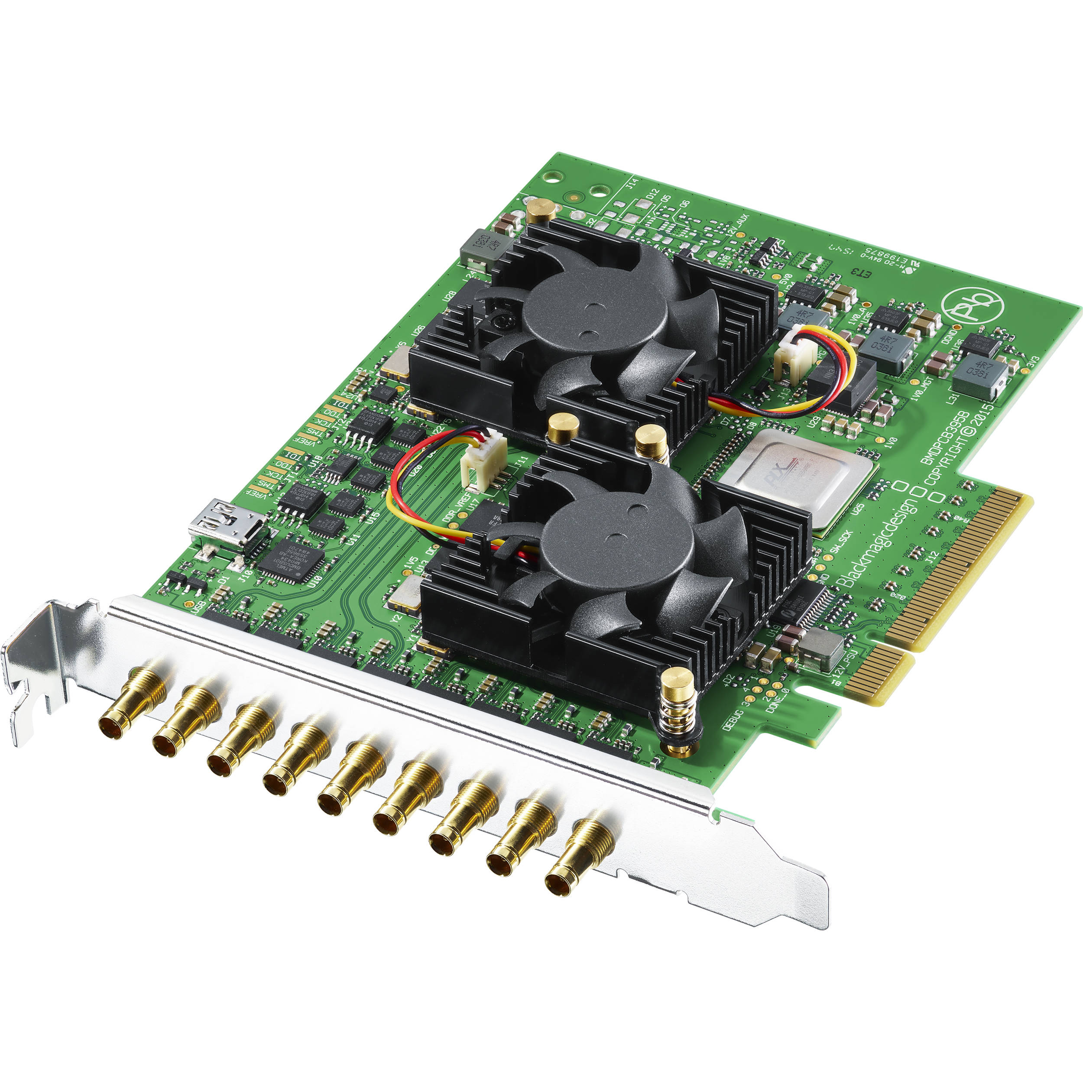
The high-productive capture and output board with a modern 12G-SDI interface for Ultra HD and DCI 4K materials with up to 60 fps frequency. The board is perfect for regular 2D and stereoscope 3D video, providing the full resolution and improved color reproduction of YUV and 12 bit RGB images with the 4:4:4 sampling frequency. DeckLink 4K Pro has two 12G-SDI inputs and outputs, supports 16 channels of embedded sound and a clock input.
ID: BDLKDVQD2

Ports Positioning
Connector numeration in Quad 2 starts from the motherboard.
The default variant of designating Quad 2 connectors in Blackmagic drivers.
BNC Connector | Blackmagic Service | Designation of virtual ports (Connectors) | Comparison to Capture services* | Comparison to Playout services*
1 | REF |  | Genlock_1 | Genlock_1
2 | DeckLink Quad(1) | SDI1 & SDI2 | Capture_1 | -
3 |  |  | Signal from Capture_1 on pass | Playout_1
4 | DeckLink Quad(2) | SDI3 & SDI4 | Capture_2 | -
5 |  |  | Signal from Capture_2 on pass | Playout_2
6 | DeckLink Quad(3) | SDI5 & SDI6 | Capture_3 | -
7 |  |  | Signal from Capture_3 on pass | Playout_3
8 | DeckLink Quad(4) | SDI7 & SDI8 | Capture_4 | -
9 |  |  | Signal from Capture_4 on pass | Playout_4
- | DeckLink Quad(5) | None | - | -
- | DeckLink Quad(6) | None | - | -
- | DeckLink Quad(7) | None | - | -
- | DeckLink Quad(8) | None | - | -
* comparison with services is given for 04, 08, 40 and 80 configurations. The rest of options are based on the described logic.
User designating Quad 2 connectors in Blackmagic drivers.
BNC Connector | Blackmagic Service | Designation of virtual ports (Connectors) | Comparison to Capture services* | Comparison to Playout services*
1 | REF |  | Genlock_1 | Genlock_1
2 | DeckLink Quad(1) | SDI1 | Capture_1 | Playout_1
3 | DeckLink Quad(5) | SDI2 | Capture_5 | Playout_5
4 | DeckLink Quad(2) | SDI3 | Capture_2 | Playout_2
5 | DeckLink Quad(6) | SDI4 | Capture_6 | Playout_6
6 | DeckLink Quad(3) | SDI5 | Capture_3 | Playout_3
7 | DeckLink Quad(7) | SDI6 | Capture_7 | Playout_7
8 | DeckLink Quad(4) | SDI7 | Capture_4 | Playout_4
9 | DeckLink Quad(8) | SDI8 | Capture_8 | Playout_8
* comparison with services is given for 04, 08, 40 and 80 configurations. The rest of options are based on the described logic.
Configuring ports is implemented in the control panel: ‘’Windows→Control Panel→Blackmagic Desktop Video Setup''.
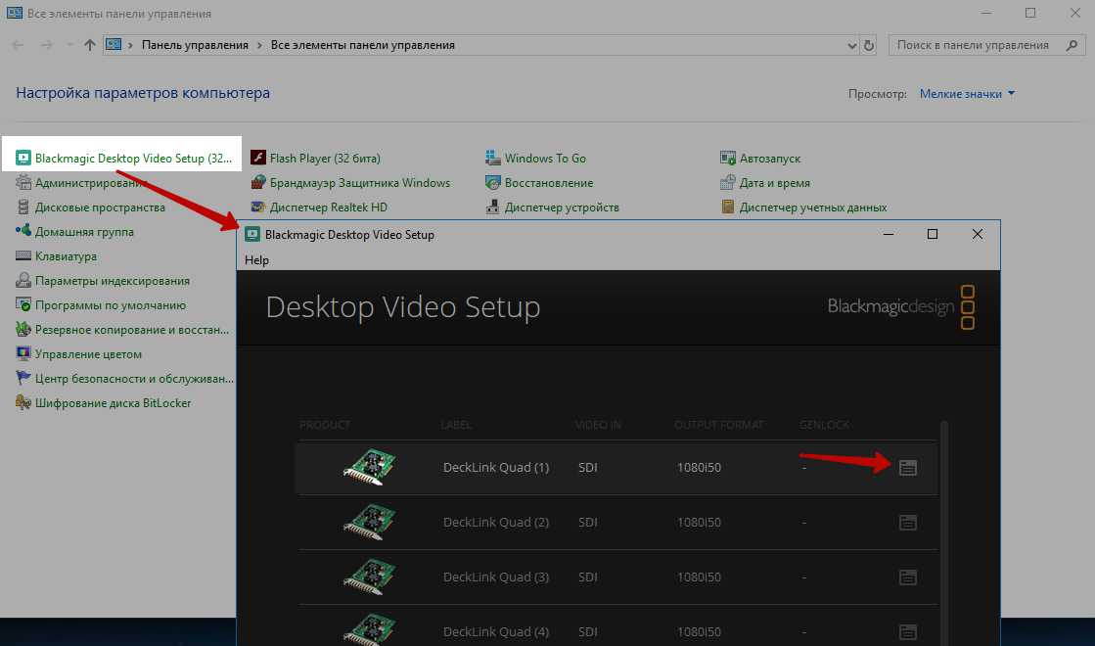
Select the needed service and move to the Connectors tab.
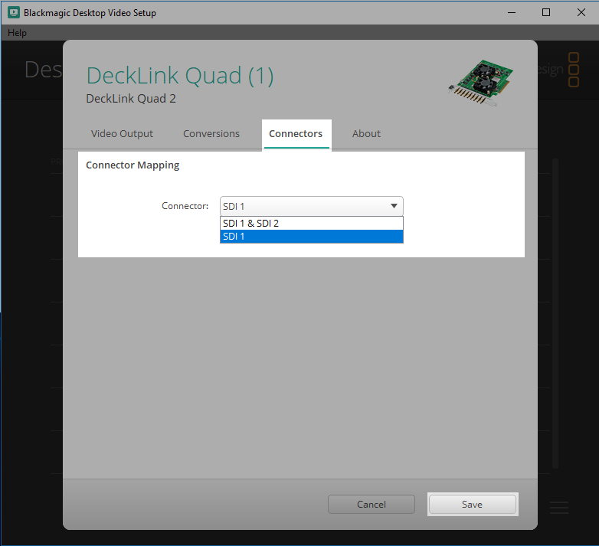

DeckLink Duo 2
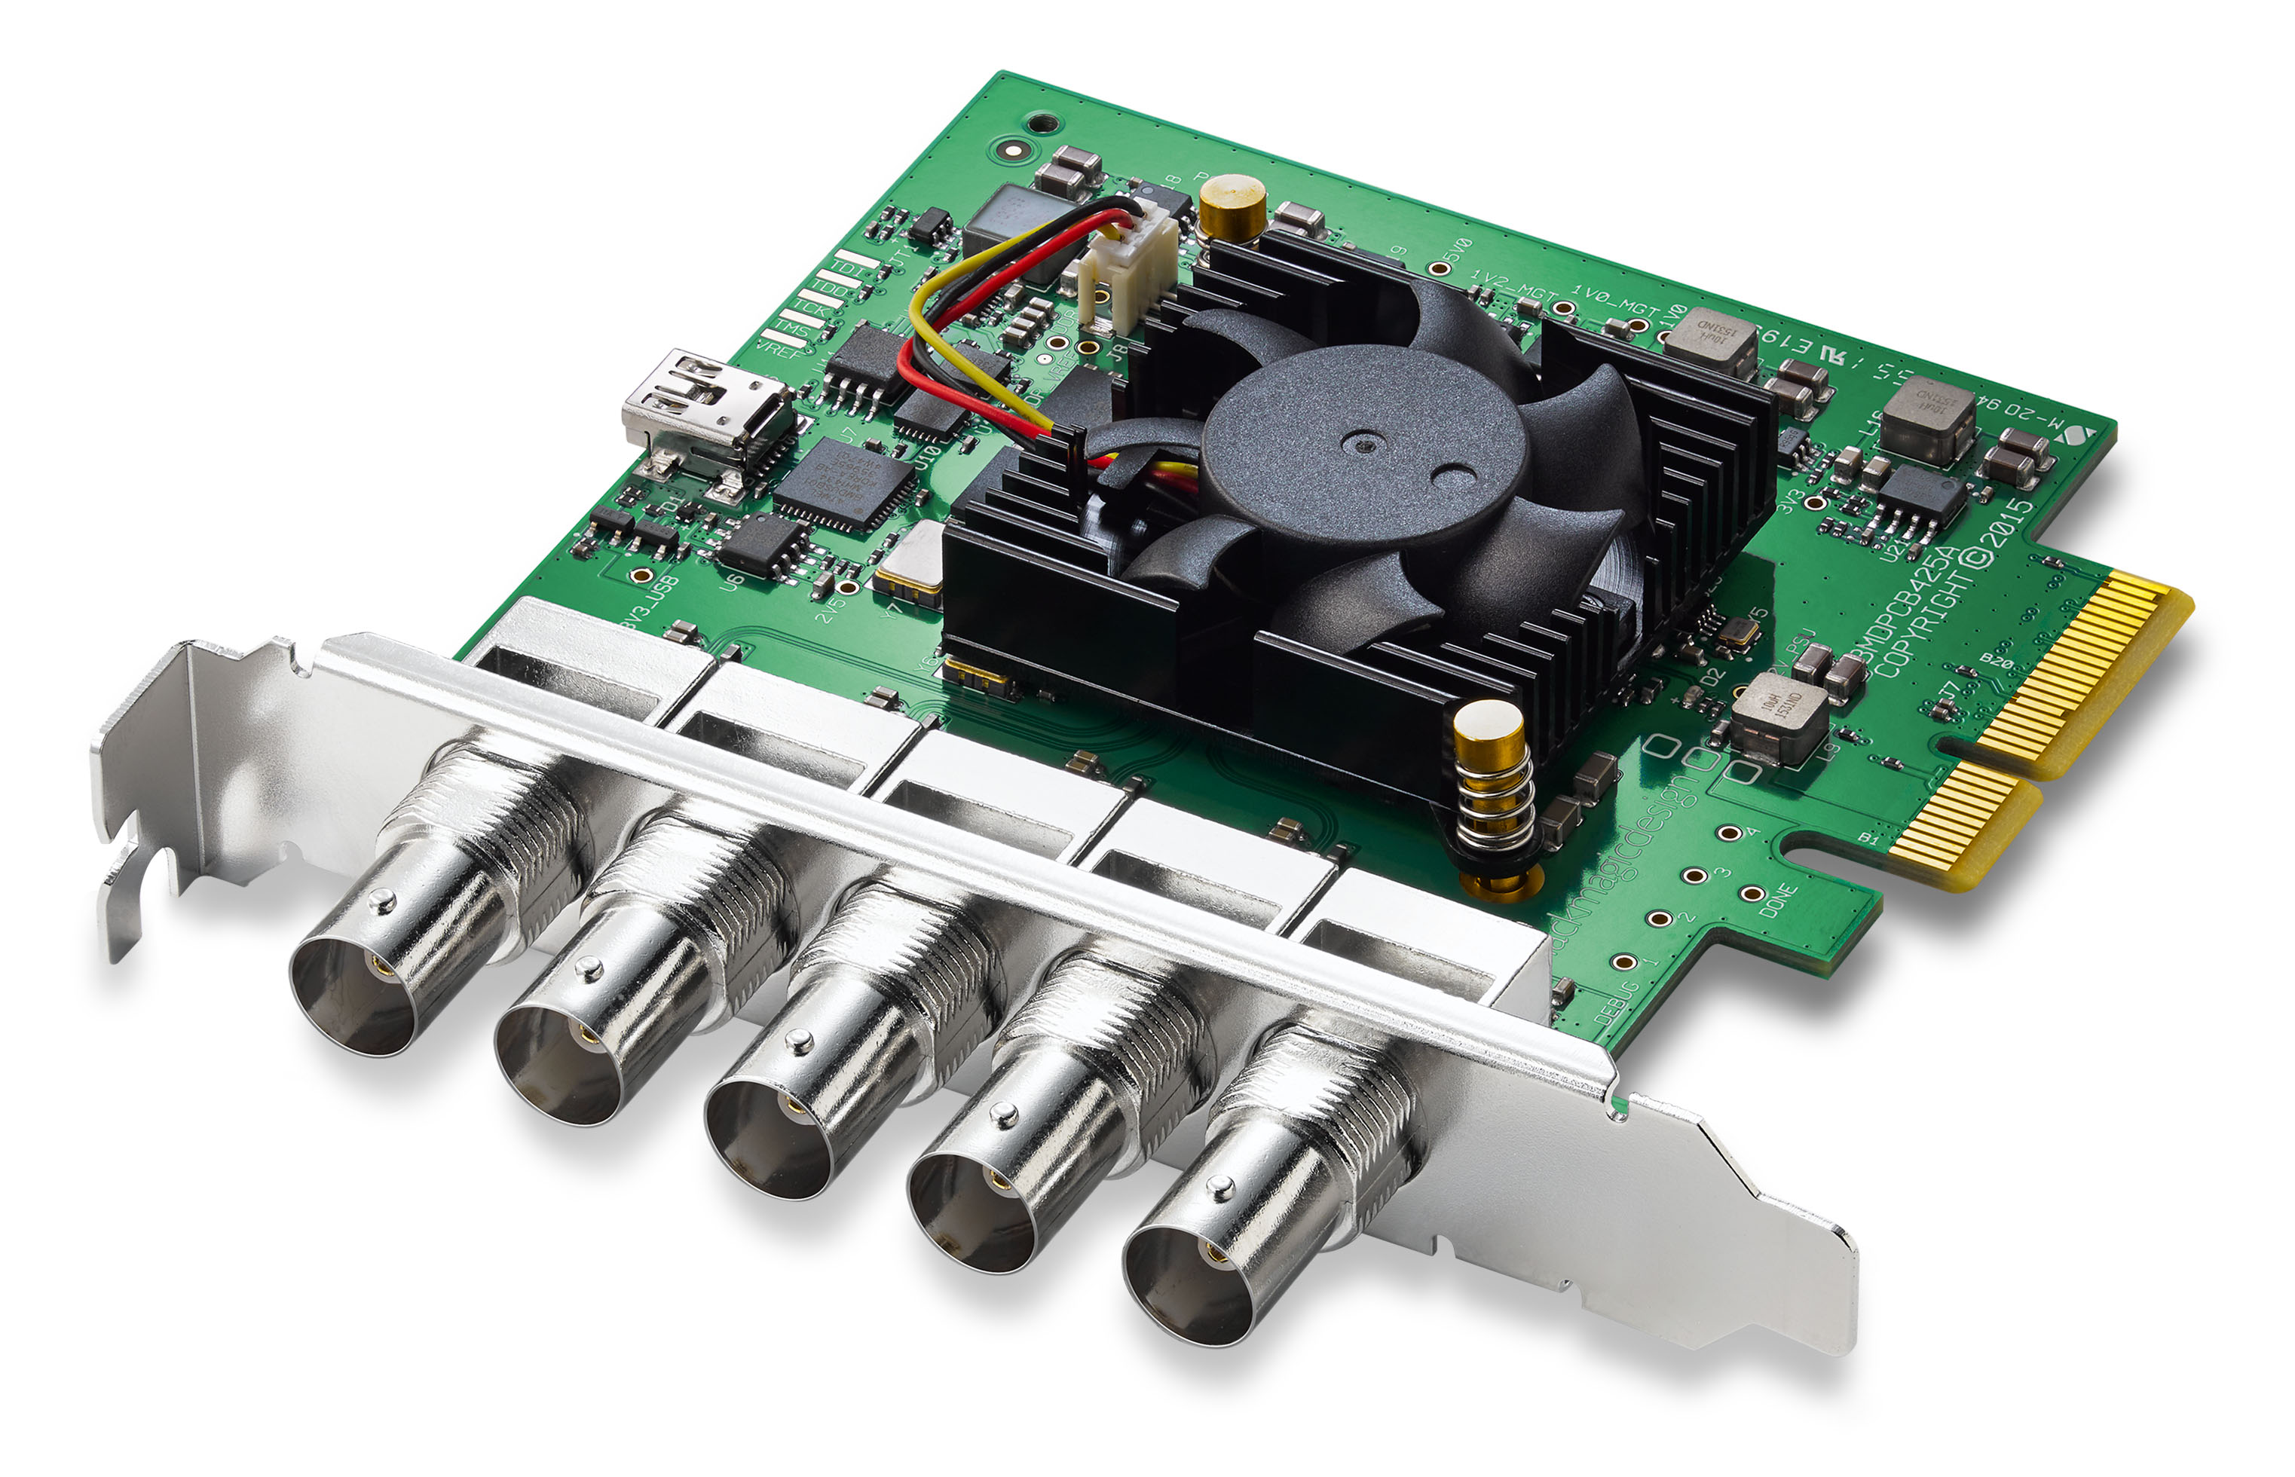
PCIe based DeckLink Duo 2 has two independent 3G-SDI interfaces that provide processing SH and HD video up to 1080p/60. Combining the functionality of four independent capture and output boards, the solution is universal and perfect for using with media-servers, digital panels and multi-channel recording systems in the real-time mode.
ID: BDLKDUO2

DeckLink SDI 4K (6G SDI)
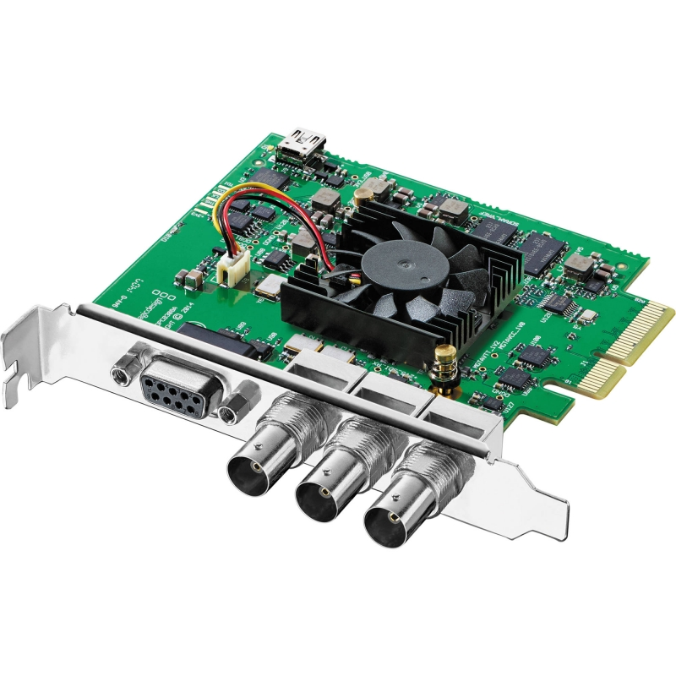
DeckLink SDI 4K is a great choice for those who work with SDI only and needs the highest recording and playback quality. The PCI Express board with 6G-SDI support can be connected to machines on Mac Windows and Linux platforms. DeckLink SDI 4K is the most compact and available video-capturing board for SD/HD and Ultra HD.
ID: BDLKSDI4K

DeckLink 4K Pro (12G SDI)
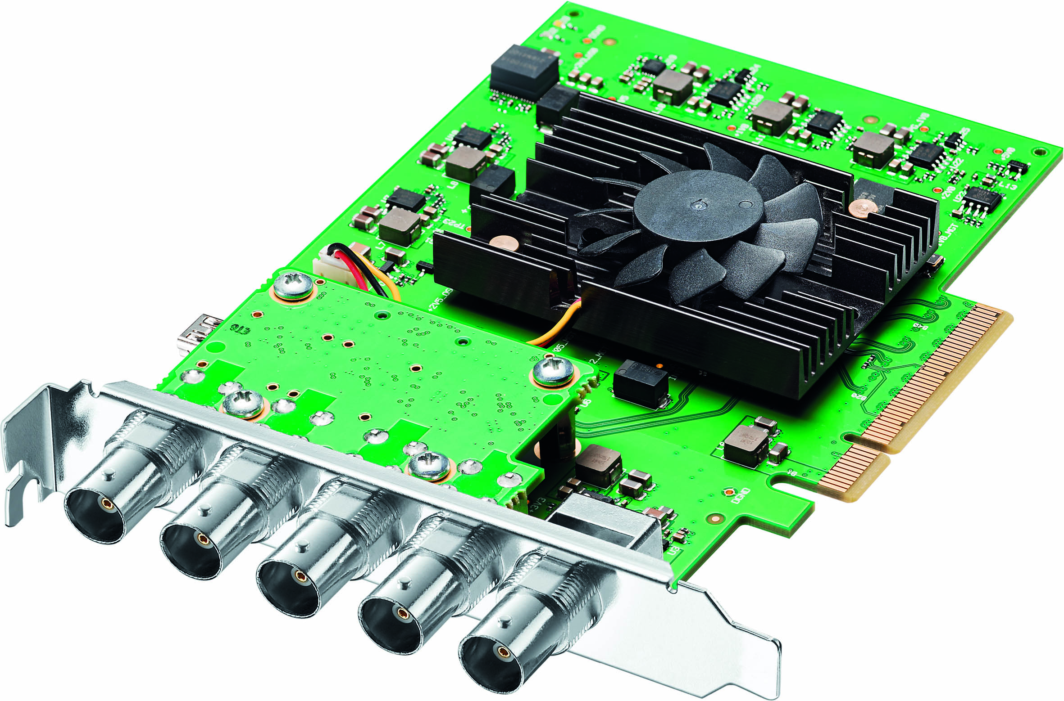
The high-productive capture and output board with a modern 12G-SDI interface for Ultra HD and DCI 4K materials with up to 60 fps frequency. The board is perfect for regular 2D and stereoscope 3D video, providing the full resolution and improved color reproduction of YUV and 12 bit RGB images with the 4:4:4 sampling frequency. DeckLink 4K Pro has two 12G-SDI inputs and outputs, supports 16 channels of embedded sound and a clock input.
ID: BDLKHCPRO4K12G

DeckLink 4K Extreme 12G (12G SDI)
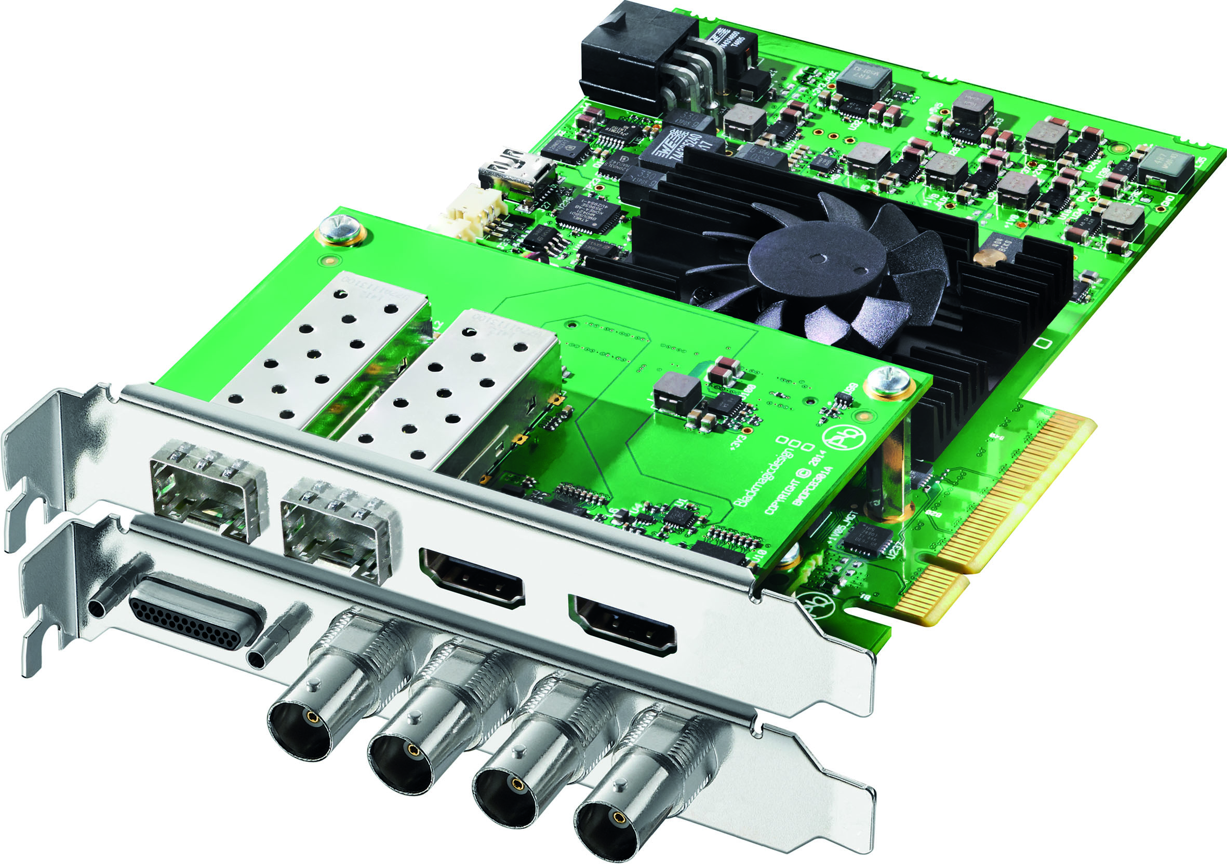
The most advanced board for processing movie materials with two channels of input and output of full-frame DCI 4K picture through 12G-SDI. The Dual Link 12G-SDI interface supports SD, HD, Ultra HD, and DCI 4K in the 4096×2160 resolution with up to 60 fps frequency. Recording 10-bit YUV- or 12-bit RGB-video can be implemented with full color range. The interface also provides: AES/EBU sound, up/down/cross conversion and built-in output of stereoscope 3D image in the 4:4:4:4 RGBA format.
ID: BDLKHDEXTR4K12G

StreamLabs

MS416
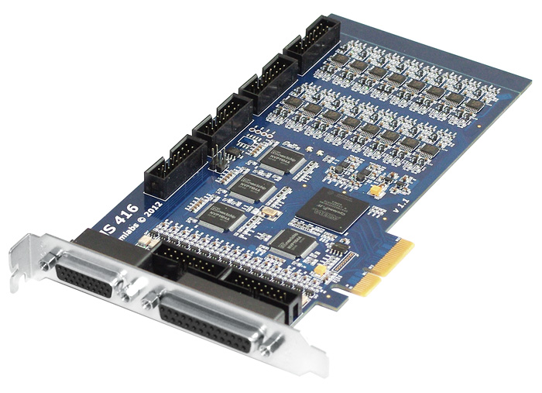
Basic Characteristics
- 16 analog video-inputs.
- 16 linear audio stereo-inputs.
- The PCI Express x4 bus.

MH4LM
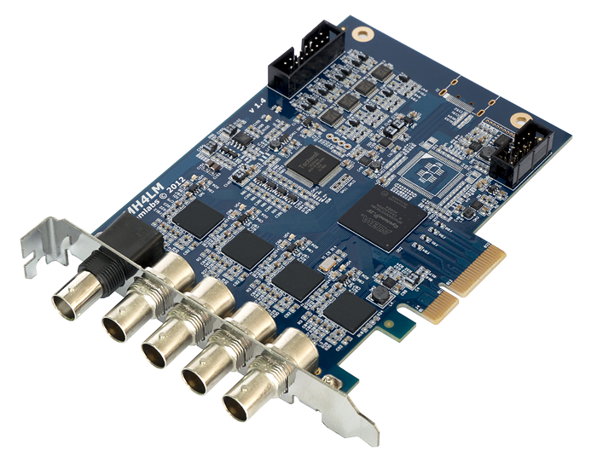
The board contains four SD-SDI/HD-SDI/3G-SDI ports and the PCI Express x4 bus.
BNC (socket numeration from the motherboard) | Designation | Comparison to Skylark services
1 | SDI In 1 | Capture_1
2 | SDI In 2 | Capture_2
3 | SDI In 3 | Capture_3
4 | SDI In 4 | Capture_4
5 | LTC In | no

StreamLabs Boards Firmware
The procedure of firmware updating:
- Request relevant update files in the Skylark support service.
- Launch SLFirmwareUpdate.exe.
- Select the needed board from the list of available ones.
- Select the *.pof file with a compatible firmware version.
- Launch the firmware process by the Update button.
- Turn off the server power for some time (around 15 sec.)
- Start the server and check its performance.
Powering down the server during firmware updating can lead to complete failure of the board.

DataPath

E2S
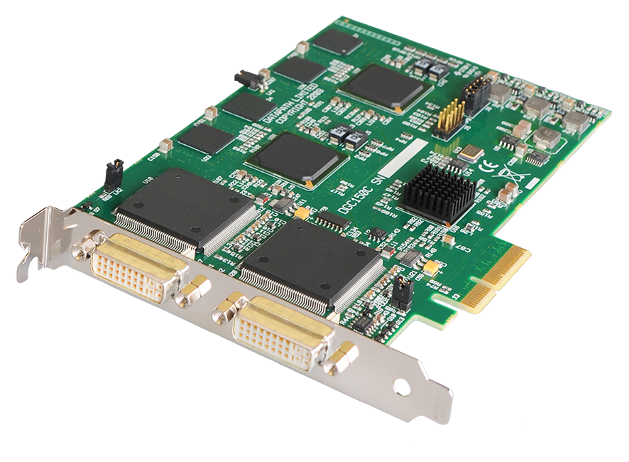
The board supports two DVI/HDMI capture channels.

Dektec

DTA-2144
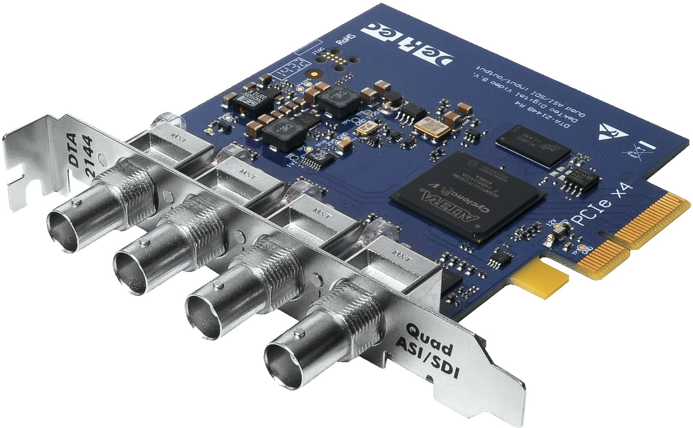
The board supports 4 ASI/SD-SDI inputs/output. The supported PCI interface is PCIe gen1 x4.

DTA-2162
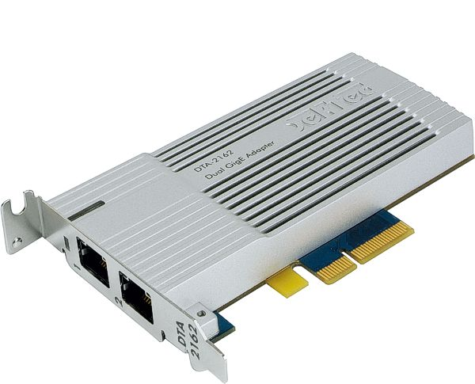
The board support is added in 2.4.149 version. Two Ethernet RJ-45 (100/1000Mbps auto) inputs/outputs with RTP (FEC optionally) or UDP support. PCI Express: PCIe x4 OS Windows: 2k8/12/16, 7, 8, 10.

