IP Playout Backup function (automatic switching of IP streams)
Automatic switching of transport IP streams from the main and backup servers works for IP broadcasting in Unicast and Multicast modes. This feature is used in N+N redundancy scheme (full 100% redundancy of servers and playout channels).
The function was added in 2.0.2, for the output module in RTMP in 2.3.112, for IP outputs on Dektec boards in 2.5.23.

Principle of operation
In the scheme, using transport IP streams it is possible to use external IP-switch for switching to reserve, nevertheless the SL NEO platform server software contains a mechanism, that allows to automatically deliver stream to corresponding multicast address from reserve server, in case of output stream failure from basic one.
The redundancy function of the output streams is implemented in the following way: the IP-address and port parameters for the output transport streams of the main and backup servers are set identically; in the normal mode the main server creates the stream, the backup server synchronously plays the backup playlist, creates its own stream, but does not transmit it to the network. The backup server playout service constantly analyzes the status of the similar IP Playout service of the primary one. In case of a service failure, the standby one broadcasts to the network to the same addresses and ports. When IP Playout service on the primary server recovers, the backup server stops streaming into the network and enters “standby” mode.

Basic mode

Standby mode
If there is no connection to the main server, the backup is automatically entered.

Setup
Options for configuring IP Playout redundancy: “Administrator Control Panel→Manage→Video IO Boards→LAN Interfaces/Ethernet Adaptor→Playout_N→Edit→IP Parameters”. These settings are made on the backup server. The main server does not require any additional settings.
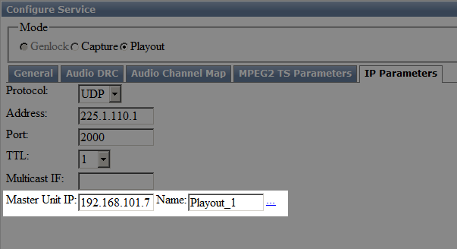\
Parameter | Value | Description
Master Unit IP | string | IP address of the main server (Localhost by default)
Name | Playout_N | Master IP Playout service on the primary server. Choose from a list.
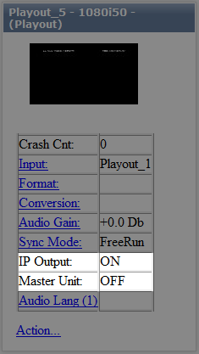
Status control on the backup server: “Administrator Control Panel→Status→Playout_N”.
Parameter | Value | Description
IP Output | ON or OFF

