Messenger
Messenger is a type of service to transmit messages in client software of Skylark SL Neo platform. Messenger is supported by version 2.4.81 or latest.

Main Features
- Client software interface.
- Message transmission to users and groups.
- Attachment of assets from Media database to messages.
- Automated message transmission by triggers.

License
Messenger License is required.

Add Messenger to Your Server Configuration
When your server is stopped, click the right mouse button on Neovid red icon by the clock. Move Messenger to the right area to add it.
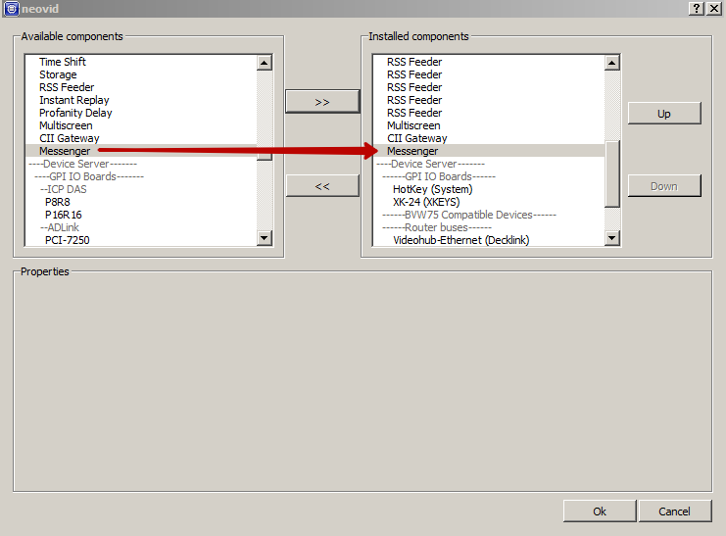
Press OK. Start your server.

Messenger Configuration
Follow the Menu to make your Messenger settings: Administrator Control Panel→Manage→Messenger→Messenger Parameters.
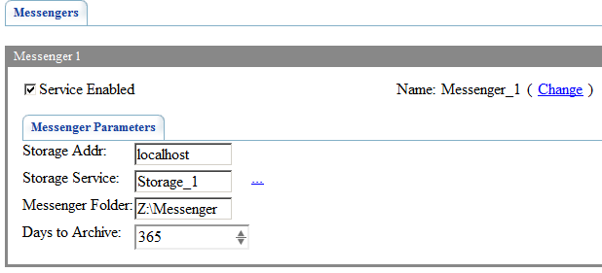
Parameter | Description
Storage Addr | Server IP address with Media database service
Storage Service | Media database name to obtain data about users or groups. Choose it from the list after IP address is entered.  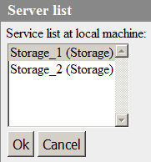
Messenger Folder | Path to message database folder
Days to Archive | Number of days until messages are archived

Client Software Settings
Follow the menu to configure Messenger in client MediaConnect and AirManager: File→Configure→Storage→Messenger.
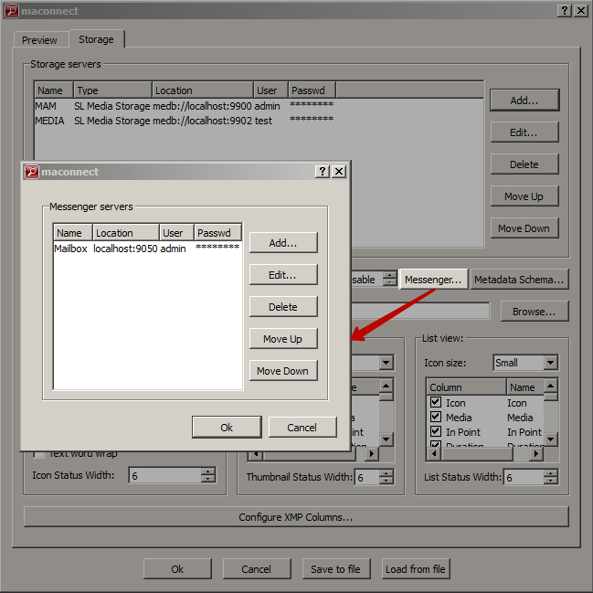
Parameter | Meaning
Add… | Create new connection to Messenger
Edit… | Edit chosen connection
Delete | Delete chosen connection
Move Up | Change connection priority
Move Down | Change connection priority
Create and edit connection to Messenger.
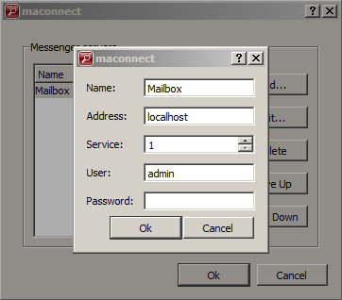
Parameter | Description
Name | Connection name which will be shown in Messenger window
Address | Messenger Server Address
Service | Messenger sequence number. Starts with 1 (one).
User | Messenger user name. This user name will be determined as message sender and recipient. This user should exist in Media database.
Password | User password

Client Interface

Message List View Window
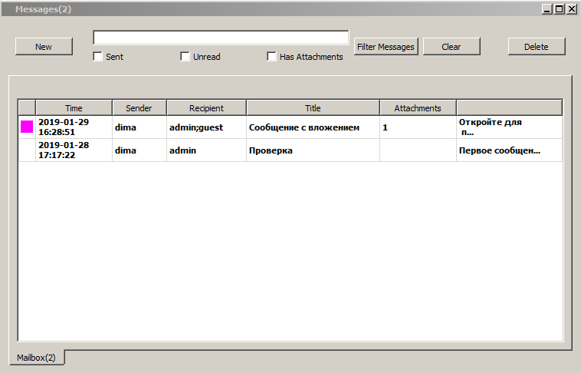
Parameter | Description
New | Open new message edit window
Поле ввода | Search query field
Sent | Show sent messages
Unread | Show unread messages
Has Attachments | Show messages with attachments
Filter Messages | Filter messages due to chosen criteria
Clear | Clear filter
Delete | Delete chosen messages
Message List
Priority | Color marker of message priority
Time | Message sending time
Sender | Message sender
Recipient | Message recipient. Multiple recipients are separated with semicolon “;”.
Title | Message title
Attachments | Attachment counter
Body | Message text

New Message Edit Window
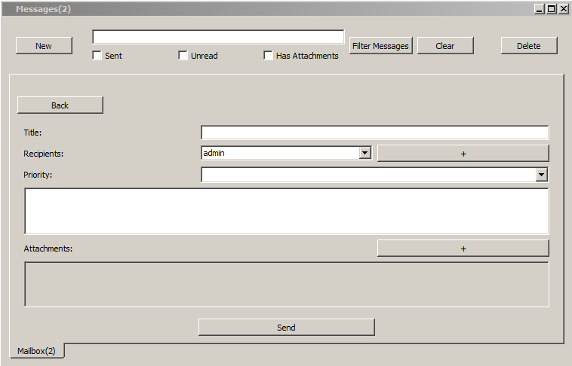
Parameter | Description
Back | Return back to message list viewer
Title | Message title
Recipients | Choose message recipients from drop-down list. Recipients can be both user and groups. Use buttons +/- to add or delete recipients.
Priority | Message priority:  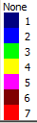
Поле ввода | Entry field for text message
Attachments | Attachment field. Use button+ to add attachments. Use button Х to delete attachments.

Message View Window
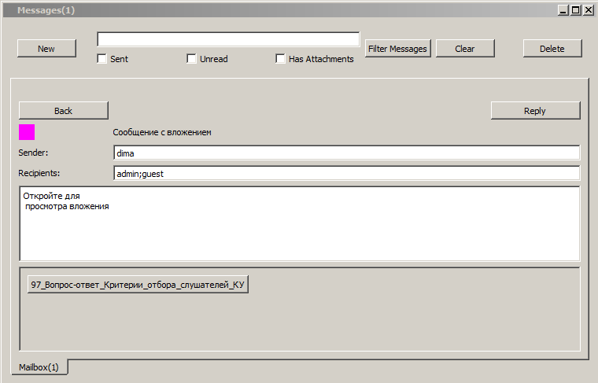
Parameter | Description
Back | Return back to message list viewer
Reply | Reply to the message. It opens new message edit window with Title and Recipient fields filled in automatically.
Sender | Message sender
Recipient | Message recipient. Multiple recipients are separated with semicolon “;”.
Attachments | Attachment field viewer. Click on the attached asset to view it in File Monitor.

