Effects of Object Appearance/Disappearance (Wipes)
In the graphics editor, Mix In / Mix Out fields set effects of appearance/disappearance of the object layer.

Examples
 | A transition template (Wipe) example at the picture is a full screen wipe: when an object appears the wipe will open it from left to right, when it disappears, the wipe will close it from right to left.Download example.
 | At the object appearance, this template will open it from right to left, at its disappearance it will close it from left to right.Download example.

Uploading to Composition
Import a static full screen file containing a black-and-white template to the server database. 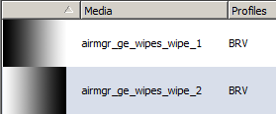
Then add the template to the composition by pressing Add (General section, Wipes window): the template will be named as wipe_1.
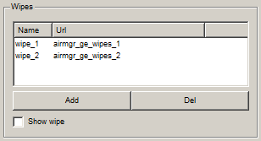
Parameter | Description
Name | The wipe effect name within a graphic composition, used when selecting an effect in object settings
Url | The Wipe effect MediaID
Add | Adding a new Wipe.
Del | Deletes the selected Wipe.
Show wipe | Show the selected Wipe in the graphics editor preview window

Configuring
Transition settings are specified at the Elements tab in object properties.
In the Elements tab, select the object and manually enter “wipe_1” into the Wipe row of Mix In/Mix Out fields.
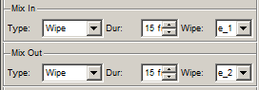
- Type – transition type.
  - Cut – default value, no effect.
  - Fade – smooth appearing (so-called mixer); specify transition duration in frames in the Dur field.
  - Wipe is the Gradient Wipe effect, using the full screen static picture with a transition template. Object transparency will be changing during the transition duration specified in the Dur field. The sequence of changing the object transparency will be maintained: from the template darkest areas, with a smooth transition to lighter ones.
  - Local Wipe – scales the transition template to object current sizes. Using this mode is convenient in case if an object is small: in this case a full screen transition may not give the necessary visual effect.
- Dur – transition effect duration in frames.
- Wipe – selecting a wipe template. Manually enter the template name specified in the list of the General tab.
To view effects in the editing window, activate the Preview fade ins/outs button in the graphics editor Top menu. Use the scrolling area.
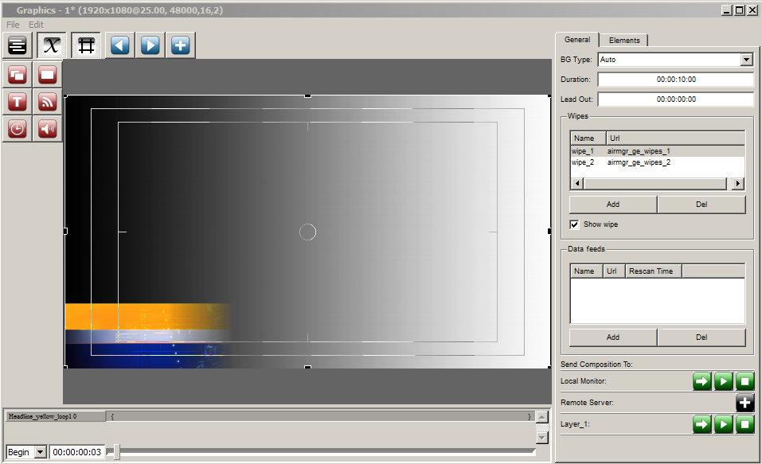
Example of displaying a transition effect in the editor.

