Clipping Rectangle
In version 2.0.63, a clipping rectangle was added to the graphics editor. It contains the intersection area that limits visibility of any graphic element anchored to the rectangle (see the picture).
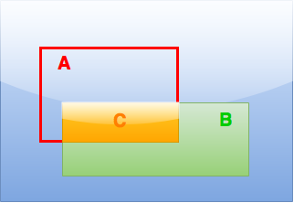
- A – clipping rectangle without filling
- B – anchored graphic element (Text, Text feed, PIP etc.)
- С – visible area

Adding and Anchoring
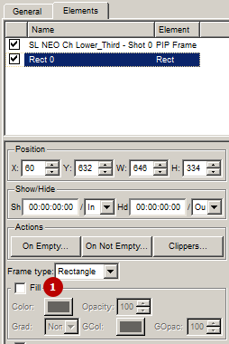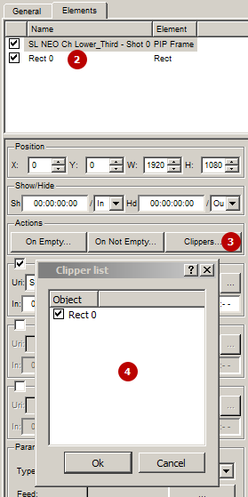
- Add a Rectangle object to the graphic composition. Turn off color filling (Fill).
- Select the object to be clipped (PIP in the example).
- Press “Clippers…”
- Anchor the clipped object to the Rectangle object by checking the box. Press Ok.
The button - Preview fade ins/outs - allows viewing the clipping result directly in the graphics editor window.
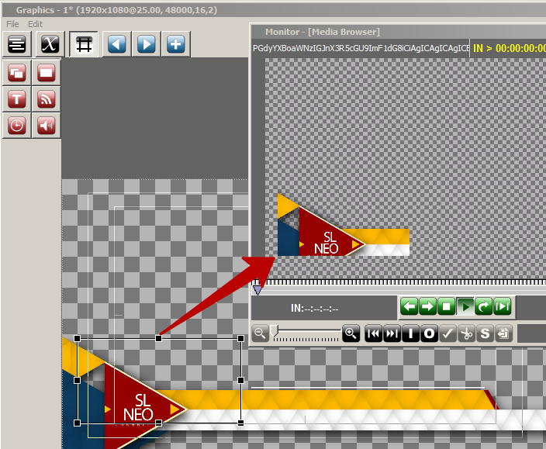
The result of clipping in the preview window.

Animation
The clipping rectangle can have an open/close animation by key points: '’Rect properties → Key points''.

